
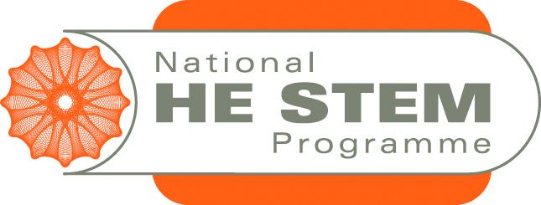
Briefing paper for employers taking part in video-conferencing event with students
Thank you very much for your interest in this project and we hope that you will be able to be involved in the “Dragons’ Den” event.
The idea of the event is for a panel of 3 or 4 employers to join a video conference in which three students each give a 10 minute presentation on a relevant topic from their studies. Each employer in turn will then have the opportunity to comment on the presentation and make their own observations of the usefulness of the study undertaken and/or skills developed by the students. The whole session will thus last for 1 hour, and the use of technology means that there is no travel time or cost, so the 1 hour of time is entirely spent “with” the students.
Previous employers who were involved in this type of project commented extremely positively about it. They particularly appreciated
- finding out what students do in laboratory sessions at university
- having the opportunity to “talent spot” good students for possible work experience/project work or potential employment
- the efficiency of video-conferencing for enabling a useful discussion between them and students
The benefits for students are primarily that they have the opportunity to hear directly from employers what techniques they use and the relevance of their university studies to the world of work.
If you are interested in taking part, we will arrange to meet up or have a talk by phone and/or video conference to ensure that everyone’s expectations are clear.

Briefing paper for employers taking part in video-conferencing event with students by © The University of the West of England 2012 is licenced under a Creative Commons Attribution-ShareAlike 2.0 UK: England & Wales Licence with the exception of registered marks such as logos. All reproductions and repurposing must comply with the terms of that licence.

This activity was undertaken as a part of the National HE STEM Programme, via the South West Spoke. For more information on South West Spoke projects, please see www.hestem-sw.org.uk. For more information on the overall national programme, please see www.hestem.ac.uk.

