
Final Case Study Report Template

IMPORTANT: The SW final report guidance document must be consulted before completing this report template. Please complete all sections.

Project Title: AGN STEM

Project Leader: Mark Thompson

Department/School:

Institution: Wiltshire College

Other institutions/organisations involved in the project: University of Bath

Abstract:
An Access Grid Node (AGN) has been installed at one of Wiltshire College’s campuses to facilitate use of high level videoconferencing for STEM employers in Wiltshire. The objective was to support employers with access to staff development spanning FE and HE (working in collaboration with the University of Bath). Extensive infrastructural work was required, including increase in bandwidth and room refurbishment. The former, particularly, required considerable time to complete.
Subsequent to commencement of the project, decisions were made to further improve the room housing the AGN and to refurbish surrounding accommodation to provide a high quality STEM Centre. Whilst this has improved the likelihood of engagement with employers, the implementation involved an unexpectedly extended period of unavailability of the service.
Multiple rounds of surveying STEM employers have been undertaken. Interest from employers has been lower than anticipated and is thought to reflect the economic environment and short term priorities of the employers. There have also been effects of government policy changes with respect to public sector STEM employers. Much effort has gone into preparing the ground for further engagement with employers after the project formally ends. This includes the refurbishment noted above, development of a formal Wiltshire College STEM Strategy, increased internal co-ordination on STEM, planning for a STEM Fair, contact with STEM Ambassadors, and refinements to the STEM employer database. There has been considerable learning with regard to the identification of relevant employers, for which there have been improvements during the project, but more analysis and planning is required.
Guidelines and training for use of this high level of videoconferencing have been disseminated internally. The college is now moving from the original AGN software to use of VisimeetTM which is evidently more flexible and likely to be more appealing to employers. A further, smaller scale and portable node is being completed for another Wiltshire College campus. This is being built by the college’s own staff based on their experience with the AGN and will use VisimeetTM. This is thought to add considerably to the appeal for employers and to more surely evidence sustainability benefits.
It is considered that continued efforts alongside improved economic conditions will see the project make a significant impact, albeit outside of the formal timescale.

List of Outputs:
- Commissioning of large screen, twin ptz camera installation with full audio management to deliver Access Grid sessions, complemented by ceiling-mounted projector and pull-down screen for “lecture delivery”:
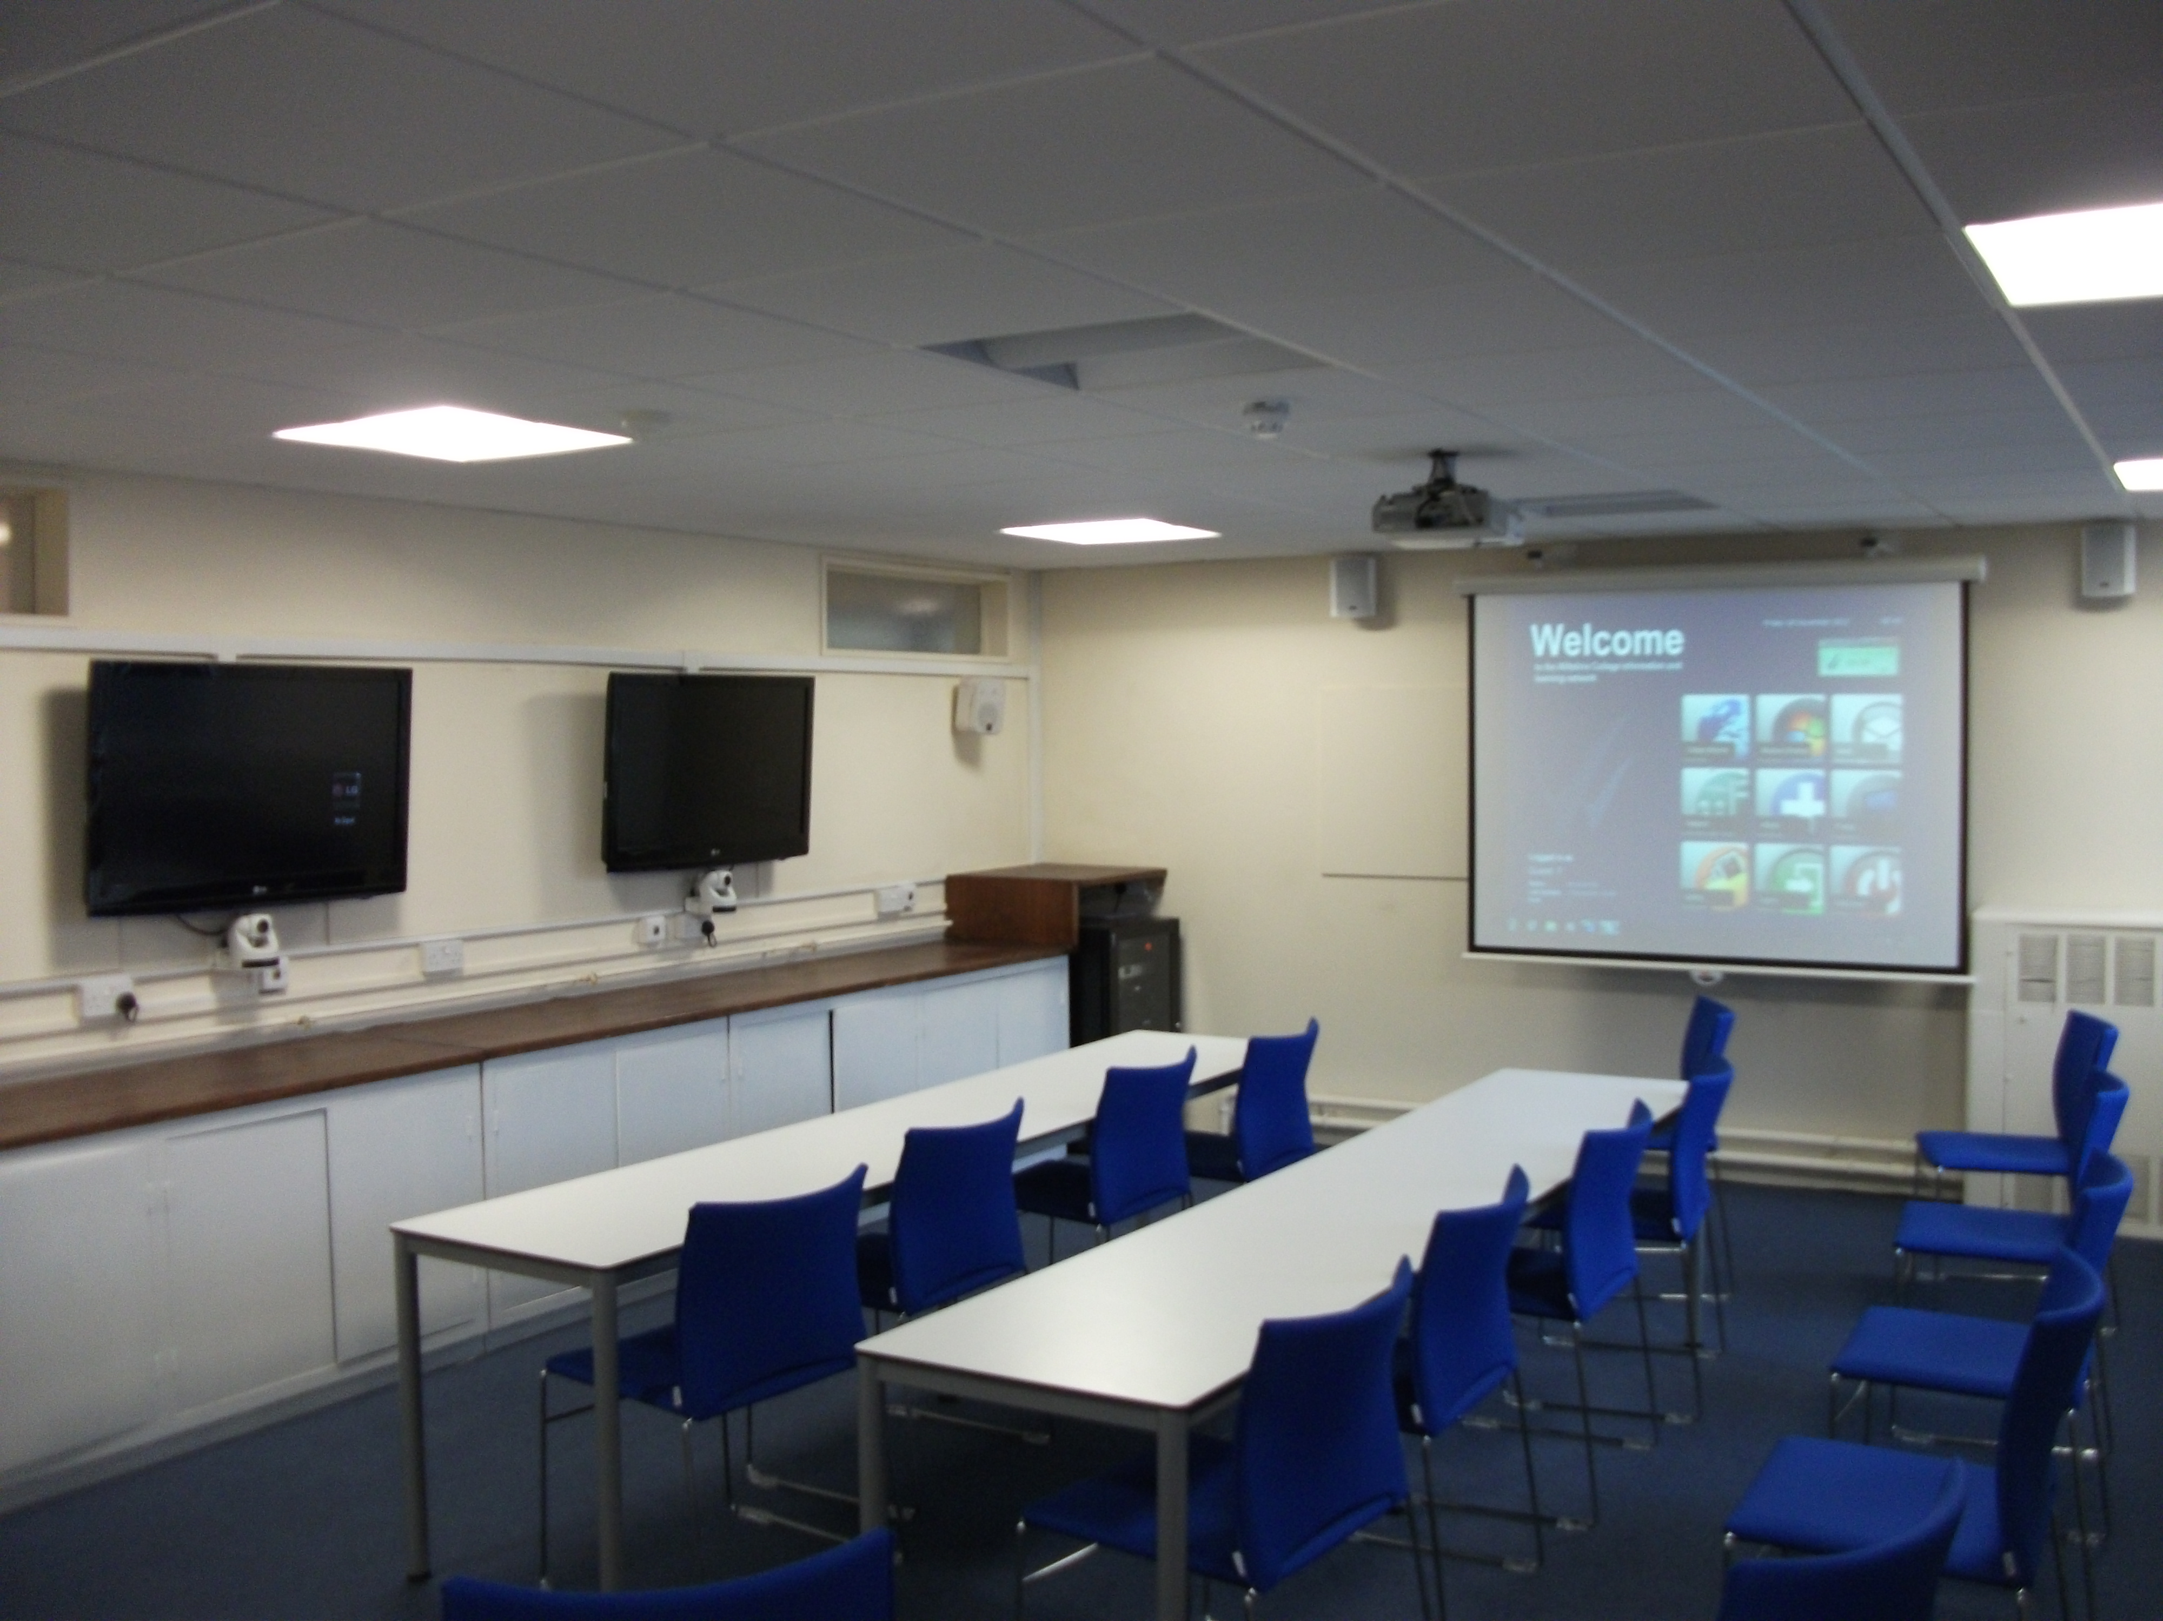
- Transfer to VisimeetTM software (currently in process)
- Refurbishment of room in several stages to achieve “business-facing” quality of environment
- Collaboration during development with AGN expert at University of Bath
- STEM employer survey of videoconferencing for training purposes undertaken and processed
- STEM employer database developed
- Staff trained on use of kit
- Review of project with STEM Ambassador
- Publication of HE STEM Newsletter article
- The project has triggered development of internal processes to steer STEM development, including the commencement of work to develop a STEM Strategy and deliver a STEM fair in the next academic year
Associated outputs funded by other sources, but integrated with this project:
- Increased bandwidth invested in for the college to support AGN
- Refurbished room itself complemented by extensive refurbished specialist facilities for STEM delivery directed at collaboration with schools in Wiltshire
- Development of protocols to ensure capacity to respond to enquiries/opportunities to work with employers and provide advice (these have been published in a national version (http://archive.excellencegateway.org.uk/page.aspx?o=324287)
- Development of sister mobile VisimeetTM supporting kit at another Wiltshire College site.

Project Highlights:
1. Recognition of the need for enhanced internal co-ordination to achieve synergies around STEM. This project made it clear that although Wiltshire College is extensively involved in delivery and support of STEM subjects, there were missed opportunities to co-ordinate and exploit opportunities. Strategic development will now focus on coherence and efficiency. The sustainability of the AGN project will benefit from this effort.
2. The college is now in an excellent position to meet STEM employer needs for access to HE and FE level staff development. There is now a full and more flexible videoconferencing infrastructure, not least with regard to the capacities of VisimeetTM to be employer friendly, ready to meet a wide variety of need. Local STEM employers who are without their own high quality videoconferencing facilities, or cannot access their facilities for various reasons, or who wish to meet face-to-face with a small number of participants, can benefit from local access points. The vision for creation of an AGN has been realised and is now enhanced by the provision of the specialist classrooms and spaces in the STEM Centre.
3. A very large number of STEM employers have been surveyed as part of the project. This has necessitated expansion of the college’s CRM database. From this, it has been clear that, whilst many STEM employers currently may be using videoconferencing for general communications, there is low expectation of the contribution it can make to development of staff at any level of training. High-end, reliable videoconferencing such as offered by AGN (which also brings access to a research community) is not uppermost in the thinking of key personnel. The general economic environment probably hindered the project, both reducing its concerns as a priority in the minds of employers and complicating the status of publicly funded potential partners. The conclusion is that the case will take longer to make than originally anticipated, but remains highly valid.

Background and Rationale:
Working with the University of Bath, the college became aware of expressed needs of major Wiltshire based STEM employers to have improved capacity to access HE and FE training locally. Significant reasons for this need were: communications demands of a rural environment, the difficulty in retaining staff in a local economy characterised by relatively few higher paid jobs, limited staff development co-ordination between employers even when they were from similar sectors, and the lack of a university for the county. Further considerations were associated with the concentration of significant STEM businesses in the isolated location of Salisbury Plain, limited employer experience in the application of available videoconferencing tools for training purposes and the need in some cases to overcome difficulties due to either hazardous or remote environments from which training demonstrations needed to be delivered. The major employers were a mix of private and public sector organisations; the latter having plans to build a training facility on its own site that could be used by others.
Access Grid (AG) technologies appeared to have potential to address many of the above concerns. Access Grid has a long history in research communities internationally and nationally. The concept can be explored at JANET (2012). The highest end conventional videoconferencing technologies would have met some identified needs, but they both lacked ready integration with the existing HE academic community in STEM areas and involved very high cost to achieve the same technical standard.
All parties involved in the early discussions saw the potential for facilitating a model of distributed learning sets with access points at the Wiltshire College, Salisbury campus and the University of Bath. It was considered that an Access Grid Node (AGN) at Salisbury could be a core component in allowing Salisbury Plain-based employers to develop a mosaic of validated, internally delivered HE level training; this could also be complemented by use of VLE tools.
In summary, the project was seen to be green, responsive to employer need and highly flexible.

Implementation:
Demonstration events in very well-equipped specialist rooms at the University of Bath and using loaned studio level AG kit in situ at Wiltshire College, Salisbury, were organised. There was extremely positive feedback to these from the small group representing STEM employers involved: the case seemed clear that the development of an AGN in this location would provide the ready access required. It could also see the consolidation of a collaborative network for HE study which would be integrated with employer needs and practices matched to flexible offers from the university, in particular. The college was considered to have potential to both deliver some of the HE study in partnership with the university and provide the FE level set of opportunities to complete the ladder.
It quickly became clear that there was little knowledge of AG technologies among major employers. This should also be seen in the light that the NHS, for example, has extensive AG use for particular areas, such as cancer research. The academic AG network is not directly linked with the NHS networks, however.
Whilst there are non-commercial implementations of AG, it was decided that for our situation use of IOCOMTM software and matched hardware was required. Reasoning was that there was no experience of AG within the college at the time and the IOCOMTM software was generally reported to be of high quality and easier to implement reliably.
For the college, there were significant financial and logistical considerations in planning an AGN at Salisbury. Even with the purchase of the kit itself under the HE STEM project, major costs were faced by the college. Firstly, there was concern that the 100 Mb/s recommended bandwidth for AG infrastructure was at the college’s current overall level and that contention issues would arise, i.e. AG would effectively impair the experience of all other users of the college network. It was for the latter reasons that testing took place on days and times deemed to be least likely to have an adverse impact, but this was not a reasonable basis on which to develop a flexible infrastructure to support STEM employers.
A strategic decision was made within the college to increase the bandwidth available. The request was put into action, but this proved to be an extended process with long timescales for response from the organisations involved (e.g. 60 days before even a timescale could be offered). To some extent the delay benefitted the college, as the charging structure altered in our favour between original request and final commissioning. This factor introduced some delay in being able to move forward with an installation.
Whilst the bandwidth was being increased several other actions were taken. A room was identified as being suitable in terms of being on the quieter side of the campus (a main road on the other side is particularly noisy), but was a former laboratory most recently in use for motor vehicle engineering classes. The room was taken off timetable and replacement accommodation found for the displaced classes. A sum of money was secured for refurbishment to a limited, but affordable level and these works were undertaken at the earliest opportunity.
Considerable guidance was taken from the Access Grid Support Service (AGSS), first whilst based at Manchester University and later when it moved to Edinburgh University. The team from AGSS proved very helpful in advising, supporting testing, problem–solving and organising infrastructure throughout the project. More local and invaluable help was also found throughout the project from Tony Gallagher, Access Grid Manager at the University of Bath.
Four companies were asked to tender for installation, based on approved suppliers. In the event, only two were able to offer stand-alone kit (the others being companies who had experience of incorporating IOCOMTM alongside other technical infrastructure.
Each tender was broadly similar, but both had to be negotiated to within the available budget. The selection was made on the basis of choice of key components, particularly the screens and microphones. A full IOCOMTM software licence was included as part of the package. Critically, a 3-year support contract was negotiated to reduce risk to the college with a new technology and help ensure sustainability of the service.
Once the refurbishments to the room were complete and the timescale for bandwidth increase was clear, the AGN installation was organised. This necessitated some further electrical and network works, particularly to manage security permissions. A quality assurance test was also required prior to being accepted on the Jan.net network. It was quickly clear that the increased bandwidth had made the critical difference and there appeared to be no adverse impact on other users even when transmitting heavier feeds, such as the desktop showing video. Audio proved to be of the standard anticipated and all were impressed.
A small initial omission was that we had to install Microsoft OfficeTM and a small number of standard tools on the dedicated PC, as this was not a standard build.
At Wiltshire College we have a staff role called ILT Aide. These colleagues are attached to the LRCs at each of the main campuses and, amongst other responsibilities, they are available to support videoconferencing technologies, for example providing training, but also supporting sessions in delivery. It was determined from early on that the Salisbury based ILT Aide would be the key operator of the AGN, the member of staff having both the technical knowledge and the interpersonal skills to facilitate sessions. To that end, the ILT Aide was trained early on by the installers and has subsequently been closely involved with all the support and implementation.
From that point forward, internal training and demonstration took place. The business facing part of the college, Wiltshire Enterprise, was the key target group. All involved were extremely impressed and considered the technology to be a genuine step change for the college’s offer. Comments typically referred to the audio quality permitting free-flowing discussion. This group used the technology to plan action to engage with STEM employers.
Despite the early positive responses, it was also decided to mesh this initiative with an externally funded (LSIS) project to develop procedures to engage with STEM employers. From the work for the latter project, a comprehensive set of procedures was produced. These covered both CRMS components and advisory pathways to, for example, suggest the types of activity for which the system could be used.
In addition, it was decided that research should be undertaken with local STEM employers regarding their current use of videoconferencing and how they might exploit the college-based AGN. An email-based survey was conducted by Wiltshire Enterprise of some significant customers, but it was determined that the returned sample was too small. Another round of surveying took place, this time employing Questionmark PerceptionTM which made data collection much easier and simplified the completion process for respondents. The survey was offered on the basis that findings would be shared with respondents, but even that incentive was insufficient to encourage a threshold of results that could be shared. A long process then commenced to try to expand our STEM employer database. This was in part limited by lack of funds to purchase databases, but also began to highlight the difficulty in determining what organisations constituted STEM employers.
At the very same time that the installation was finally in place, a change of government and policy was beginning to have an effect. Considerable uncertainty about the future and location of a key public sector partner removed them from the picture.
Leading up to and during the summer of 2011, another college project impacted on the AGN room. Wiltshire Council funding for the development of STEM Centres to support both local schools and college students became available. In fact, the funding supported developments at both Salisbury and Trowbridge campuses. As a result major refurbishment of classrooms and labs surrounding the AGN was undertaken.
The AGN room was considered as complementary to these refurbishments. There was a clear opportunity to exploit synergies to, for example, foster links for employers across the education spectrum from HE to schools. Additionally, some work to the surrounding rooms meant that changes needed to take place in the AGN room, particularly where electrical, gas, heating and ventilation was concerned. It had also been noticed that there was a problem with lighting in the AGN room, where some older fluorescent fittings were causing interference during sessions. All these factors meant that the AGN was out of action for a period before and well after the summer break. Contractor overruns compounded the situation.
At the beginning of the project, it was known that IOCOMTM were on the brink of releasing their VisimeetTM software in the UK and that this might offer new possibilities for both integration and engagement with employers. The licensing for this software allows free short term, but operationally adequate licences to be taken by end users. It is also capable of directly connecting with H.323 systems. As a result of this, towards the end of the project period, work has commenced to install VisimeetTM in replacement of the IOCOM2TM software.
To further extend the appeal to employers of the service offered through the college, the STEM Centre funds at Trowbridge have contributed to the building and licensing of a mobile AGN/VisimeetTM installation. This is currently being built by the college’s own staff.
The project originally envisaged delivery of sessions employing mobile cameras. We are confident that this is possible, although we have not had opportunity to try this in the field from remote locations. Again, however, this looks possible albeit expensive to achieve.
Once an extension to the STEM employer database was achieved, a further round of surveying has taken place. An additional sample of 229 organisations was contacted, with to date only two returns.
Some early consultation with a STEM Ambassador has taken place regarding the project. Possible input will be to offer masterclass type activities as demonstration events; the hope being that the direct access to expertise may trigger new thinking by employers.
The project has triggered a much closer internal consideration of activity around STEM. As a direct consequence a STEM Steering Group and associated STEM Curriculum Group have been formed. An early target is the creation of a STEM Strategy.

Evaluation:
A survey using both email return and online questionnaires was conducted in multiple phases (total = 669 businesses approached). The small number of returns (total = 19) from all phases of survey does not permit valid inferences to be drawn, but the initial picture is one of only two respondents using videoconferencing in a training context. Of these, neither was interested in working with the college to engage in collaboration with other employers for staff development.
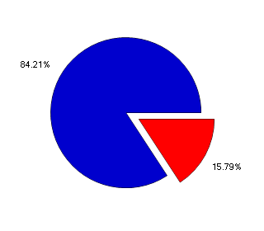
Fig. 1 Local STEM employers using videoconferencing as part of their business:
Blue = no; Red = yes; n = 19.

Informal discussion with employers visiting the facility was noted and continued to be encouraging.

Discussion, Learning and Impact:
The economic environment has not been friendly to the project. This has been strongly reflected in the uncertainty around a major public sector partner, but is also thought to be shown in the difficulty in gaining interest from the vast majority of employers. It is hypothesised that employers are less inclined to engage in activity that appears to be outside of their immediate business concerns. However, the economic case for local access to videoconferencing and the flexibility it provides to employees and employers is very likely to return to the agenda when the economy begins to improve. At that point, it is also likely that there will be an increase in labour market tensions that will reinforce the case for local access to HE qualification and development.
An environment and facilities of a high standard are now available for use by local STEM employers to meet HE and FE level staff development needs. The decision to refurbish surrounding rooms remains correct, but did suspend activity with the project at a critical period. However, the outcome is that the AGN room itself is upgraded to a business-facing standard and the surround suite of rooms lends itself very well to delivery of STEM events. In fact, attendees at the official opening of the STEM Centre at Salisbury showed considerable interest in the AGN facility. The full suite of rooms is to be used for a STEM Fair scheduled for November 2012. This is being pitched to involve STEM employers, local schools, the University of Bath plus members of Wiltshire College. The AGN facility will also allow us to link using VisimeetTM software, connecting both Trowbridge and Salisbury, but potentially international participants.
The risk taken in suspending use of the AGN room during refurbishment was appropriate, but does highlight the unavoidable importance of infrastructure to support a project such as this. The kit is much better served by the upgraded accommodation and better received by users.
VisimeetTM in general appears likely to make a real difference to the appeal made to STEM employers. This view is based on its ease of use, capacity to deliver ptz control, high quality audio and video, and ability to integrate with existing set ups (whether IP based or H.323). A small minority of STEM employers are concerned, due to the nature of their business, about the need to use secure networks. This is an aspect to explore with regard to VisimeetTM.
Altogether, there is now greater likelihood of long-term engagement with employers. It is considered that a longer timescale will see the potential for the initiative being drawn.
The college’s best efforts to contact STEM employers have not made sufficient breakthrough. The survey return, for example, remains inadequate for publication. Its response rate was, however, almost exactly at typical levels in our marketing experience. A longer timescale is required to extend contacts. Despite the limited responses, the combined survey results should contribute to engagement, particularly to reinforce the case for using the facility to help meet HE learning and development needs for STEM employees.
A Wiltshire College STEM Strategy could have made the implementation of the project considerably easier, by facilitating internal refocusing on STEM co-ordination. The project has probably only reached the stage where opportunities and synergies are beginning to be drawn. One area that will need to be further developed is the relevant local and national definition of what type of organisation constitutes a STEM employer.

Further Development and Sustainability

Will the activity continue in the future?
(a) Yes (in its current form) (b) Yes (in a modified form) (c) No/Unsure

If you answered (a), how has this sustainability been achieved and in particular how have you enabled the activity to continue without HE STEM funding or direct support?

If you answered (b), how will the continuing activity differ, for example, in its structure or delivery? How will the activity be sustainable and continue as a result of this modification?
Additional methods will need to be determined by which to link with STEM employers and incorporate the videoconferencing technology. A small set of further surveying will take place to those businesses whose contact details proved incorrect. The STEM Fair will be a valuable event in itself, but it is also thought that during its planning there will be opportunities to engage employers with the kit and VisimeetTM. Greater co-ordination arising from the STEM Strategy should increase the capacity of the college to respond to and create interest. In fact, for some developing activity such as a knowledge transfer project, the facility is likely to prove very significant. The college will also be able to revisit the approaches taken for business facing support.
If you answered (c), what has prevented the activity from becoming sustainable? What will now happen to the activity?

If you answered ‘unsure’, upon what does sustainability depend?

In relation to the approaches to sustainability outlined below, we are very interested in activities and commitments which have occurred within the timescale of the project. However, we recognise that some approaches may still be in the development phase at the official project end date and it would also be valuable to include these examples in the template.
Approaches to Sustainability | In relation to your project
Continuance (finding alternative sources of funding) | - The college will continue to fund increased bandwidth to support the system  - The Trowbridge “node” will be put into operation using external funds  - A VisimeetTM annual fee will continue to be paid  - Further work with STEM Ambassadors is planned  - Another round of survey is being planned once contact details have been confirmed for a small group
Embedding (within institutional activity) | - A STEM Strategy will be developed  - Specifically STEM curriculum teams will be set usage targets
Mainstreaming (changes in working practices) | - The STEM Fair will serve to mainstream the facility  - Cross-institution curriculum events will draw upon the facility and, hence, continue to demonstrate its potential
Legacy (passing on important elements of the project) | - When/if more survey evidence becomes available, the college will share findings with participating employers  - Procedures continue to be available nationally

References:
JANET (2012) AG Collaboration [WWW] available at http://www.ja.net/services/video/agsc/AGSCHome/ (accessed 1/5/12)

Quotes:

