
Name: | Peter Myler & Brian Pederson
Position: | Professor & Senior Lecturer
Discipline: | Engineering
Departments involved: | Faculty of Advanced Engineering& Science which includes Mathematics
Schools, Colleges and Exam Boards involved: | Bolton College, Bolton Six form college, Holy cross Bury, Bury college, Bolton foundation year Board, Primary engineer, Engineering Ambassador Scheme,IMechE
Date of report submission: | 20/7/12

Teaching Advisory Board (TAB) Report
(Call funded by the HE STEM Curriculum Development Special Interest Group)

Summary of Activity
Please list the activities and outputs of your TAB.

- Development of a common framework for foundation year students, College students and a first year engineering students.

- Identify the mathematics levels needed by students from non-traditional routes and qualifications

- Produce shared coursework for University and college pre degree students in engineering applications

- Developed diagnostics tests (on- line) for pre HE students to aid transition and help tutors.

Challenges
What were the challenges faced in setting up and administering the TAB? How did you overcome these?

Dealing with different University and college systems. We had to meet our colleagues over a long period to understand each other’s systems. Fortunately, we were close geographically and this could be done face to face.

Loss of local academic staff due re alignment of the University. The University restructured its academic staff during this academic year and we lost key members of the faculty including the Head of Engineering and many of the staff duties we changed. The team working on this project were particuarly affected by these changes. This caused delays in many of our activities.

Understanding the different routes for non-A- level students and how to align them with University expectations, in particular the levels of attainment in Mathematics. After lengthy discussions with our college colleagues we discovered that the majority of students studying vocational routes were grossly deficient in many of the areas of mathematics and this has a large impact for students wanting to progress to HE. We have therefore devised diagnostic systems to try to identify this in potential students. The local college is also looking to develop more mathematics in their vocational programmes and greater contact time.

Recommendations
What would you recommend other HEIs do differently when setting TABs? Any recommendations on the activity or processes?

We would encourage any HEI to work with their local college/School regarding preparing students for University education particularly Engineering as the subject has little exposure in Schools and teachers have little knowledge of the subject and disciplines involved. We also participated with the School and college teachers in the “Engineering your future programme” explaining to six form college Science teachers in Greater Manchester about engineering programmes. This activity complemented our activities and introduced us to a large group of teachers. It would also be useful to produce formalise any agreements where possible.

Impact on Institutions
How has this encouraged a wider change in practice across subject areas, faculties, departments or amongst individuals?
We now work very close with our college partners especially in the STEM subjects. We have formulation a joint proposal with the local college and the IMechE to encourage variable entry routes for STEM subjects with a potential shared laboratory provision. (see Appendix)

Sustainability
What evidence of commitment supports the sustainability of this approach?
We now have a better understanding of the various non-traditional routes to HE taken by college students and have put in place specialist support structures for these student prior to entry to HE. We also have recently (May 2012) revalidated our Engineering Foundation year and Degree Programme in line to help the smoother transition for students based upon our discussions with our local colleges.

See also appendix for new strategy with the local college

Appendix

Proposed areas of collaboration with Bolton College:
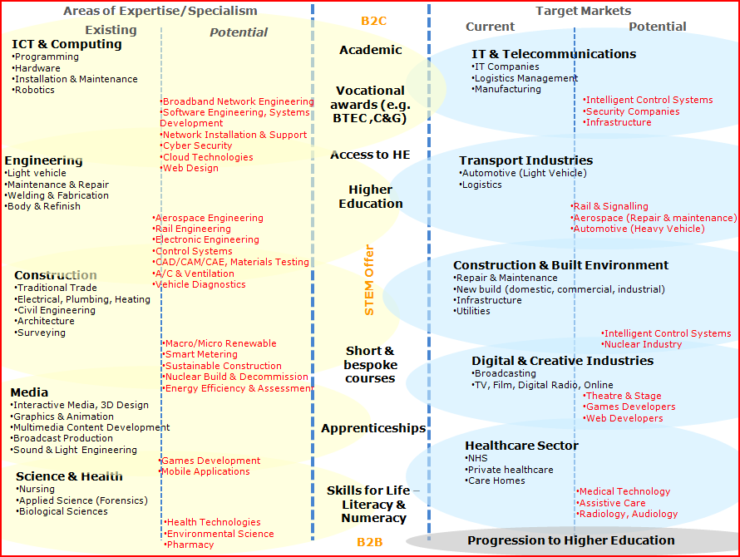

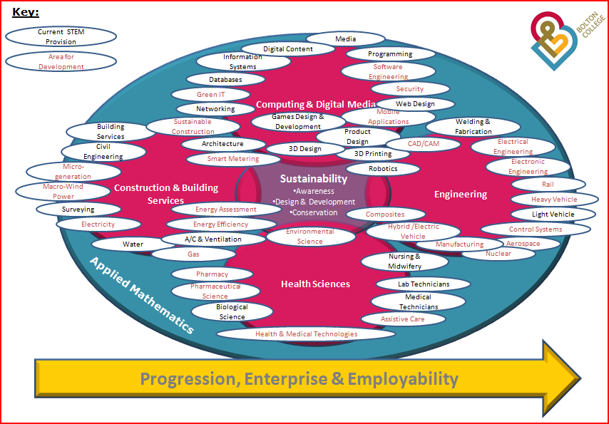

Proposed STEM changes and activities with Bolton College and University

