
Final Case Study Report Template

IMPORTANT: The SW final report guidance document must be consulted before completing this report template. Please complete all sections.

Project Title: Technology-enabled employer engagement in analytical chemistry

Project Leader: Dr Carolyn Morton

Department/School: Department of Applied Sciences

Institution: University of the West of England

Other institutions/organisations involved in the project: Bournemouth University

Abstract:
This project was designed to determine the most appropriate system that would enable employer engagement with analytical science students via the use of technology and to integrate the use of the technology into the curriculum of the undergraduate Forensic Science course. From the communication technologies available, two were selected representing the best available meeting/conferencing technologies; videoconferencing (VCON) and the online FlashMeeting (FM).
Volunteer students from the UWE Instrumental Analytical Science (IAS) module presented a 10 minute presentation based on a practical analytical technique learned in the course, followed by a 10 minute feedback from the employers. The presentations were recorded and all students on the IAS course were required to complete a 400-word assessment based on the employers’ feedback. The acceptability of this protocol was evaluated from the responses from the three different groups; presenting students, non-presenting students and employers.
VCON and FM were both found to be fit-for-purpose and acceptable to both students and employers. The two systems had complementary strengths; VCON was an excellent quality and stable system with limited uptake in industry because of initial setup costs, whereas FM is free and does not incur setup costs but is susceptible to connection problems and a lack of audio and video quality. Both systems are acceptable to employers, although VCON was the technology of choice. FM may become more viable with improved internet speed and connection stability, and from the improvement of mobile technology.
The presenting students and employers viewed the engagement as constructive and a valuable experience. The standard of the presentations and the encouragement to the student from the employers were highly appreciated. The quality of communication was vital to the positive experience of both these groups. The non-presenting students were rather negative about the assessment, but the reasons for this are clearly defined and discussed. In subsequent years it will be eminently possible to address all of these concerns based on the learning experiences of this initial year.
A measure of the success of the engagement has been the willingness of the employers to participate in future years and the commitment of UWE to continue the employer engagement with limited modifications for the IAS students and potentially other forensic science courses involving analytical techniques.

List of Outputs:

The three main outputs from this project were:
- The development of appropriate modes of interaction based on videoconferencing and online-meeting technology embedding the experiential added-value of employer engagement within the analytical chemistry undergraduate curriculum.
- Implementation of an assessment procedure for the students to evaluate the relevance of their skills for industry as an integral part of their curriculum.
- The provision of feedback and production of guidelines for translation to other STEM disciplines and adoption of a similar approach to employer engagement with students by the wider HE community.
A general set of guidelines for the development and operation of this type of employer engagement with students is described below:
- Identify a module with clear relevance to a number of employers within a defined sector. The inclusion of an applied case study or practical element is preferred.
- Contact employers requesting 1 hour of their time (for 3 presentations) and specifically request that they say something relating to the usefulness of the particular techniques in their workplace, for the benefit of all students. The benefit for them is that they find out what is being taught in the course, and potentially identify good students who may be able to undertake a collaborative project in their final year, or undertake a work placement, potentially leading to employment. Early contact and continued communication with employers is essential.
- Recruit volunteers from the student population to prepare 10 minute presentations, and provide support to them. Students should only need advice on the structure of the presentation; however they may need plenty of encouragement.
- Develop an assessment for all students (e.g. a short piece of written work reflecting on the usefulness of a technique in industry, to be written after listening to contributions from employers). It is important to strictly limit the assessment to the employers’ contributions to avoid any critique of the presenting students and any resulting embarrassment for the students.
- Familiarise all those involved in managing the engagement with the technology and practise setup and operation. Involve technical staff as early in the process as possible.
- Organise the technological aspect of the "Dragon's Den" exercise (3 students per hour, 10 min presentation + 10 min discussion with panel of 3-4 employers) and undertake a practice run to test the connections and equipment. FlashMeeting requires the organiser to register to use the Open University site at http://fm.ea-tel.eu. If aiming to use VCON, establish which companies have this system - an alternative is to join the event by phone. Check if technical support is available during the time of presentations and check that all users are familiar with the equipment. For both systems, ensure the participants are not likely to be disturbed, e.g. by phone calls, for the duration of the event.
- Check connections with each employer to ensure compatibility of the VCON systems to be used and any issues relating to connection to the FlashMeeting.
- Allow plenty of time at the presentations - setup inevitably takes longer than expected and employers and students appreciate the opportunity to have informal conversations with the students following the presentations.
- Evaluate the exercise, incorporating good suggestions for improvements from students, employers and technical staff.
- Ensure any marking of the assessment is carried out objectively within a structured framework. Given that it is a novel assessment, students may need reassuring about the marking system.
Our experience in the project showed that above all it is important to maintain communication with the employers and students to address any difficulties that will arise from the planning stage and to allow prompt action if any of the participants cannot take part.
The results and conclusions from the project have been disseminated in various formats including at the National HE STEM Programme Seminar at Bournemouth University on 25th May 2012. Regular update reports have been submitted to the SW Spoke and at face-to-face, telephone and online meetings with the Get STEM working project team. Reports have been given to colleagues at UWE, especially those involved with the Forensic Science and other science courses, via individual discussions, presentations at course meetings and at annual UWE Learning & Teaching Conference (26th April 2012). It has been possible to give feedback to the students and employers involved with the project.
The project and its results were also included in a presentation entitled; “Technology enabled engagement between employer and student to improve employability”, presented at the 9th ALDinHE Conference; "Learning Development in a digital age: emerging literacies and learning spaces" (University of Leeds, 2-4 April 2012). Information about the project has also been disseminated to the Royal Society of Chemistry via the RSC Programme Manager for Analytical Sciences.

Project Highlights:

1. The successful use of online meeting technology (i.e. FlashMeeting) and videoconferencing technology to enable effective engagement between students and employers.

2. The successful integration of the technology-enabled contact into the undergraduate year 2 IAS practical course to assist the students to appreciate employer demands by a short assessment based on recordings of the meetings.

3. The overwhelmingly positive reaction to the presentations by the presenting students and participating employers.

Background and Rationale:
The aim of this project was to examine the usefulness of novel technology (e.g. video conferencing and online meeting technology) to enable engagement between employers and students that would otherwise not be possible because of time and cost limitations.
In summary, the objectives were:
- Working with employers to identify modes of interaction which would embed the experiential added-value of employer engagement within the STEM undergraduate curriculum
- Designing a framework in which undergraduate students undertaking analytical science courses could participate in employer engagement via novel technology
- Formulating a formal assessment procedure to enable students to evaluate the relevance of their skills for industry as an integral part of the curriculum
- Providing feedback to enable the engagement experience to be enacted in other student groups.
One of the key learning outcomes which students gain from employer engagement is the constructive discussion and analysis of student-led presentations of analytical techniques that are relevant to employers. For the students presenting their work to employers it provides a valuable experience in articulating and defending their results and also gaining a different, and employment-related, view of what they have undertaken. It is aimed to help the student gain confidence in both their presentation skills and in their abilities within analytical science. There is also significant value to employers who are working in appropriate employment sectors in taking an interest in the students’ work. For the employers it provides an insight into the analytical skills the students are developing and highlights potential skills that may be of interest to them for current or future applications, and individuals whom they may wish to take an interest in and help develop their analytical skillset pre- and post graduation. The students and employers do not have this kind of engagement opportunity by any other means during the degree course. This is particularly important with respect to the forensic and analytical chemistry employment sectors. These sectors are characterised by geographically disparate small and medium sized companies that can be problematic to engage by individual students. They can be comprised of highly specialised enterprises focussing on individual analytical techniques to large multinational companies with a wide range of target markets and a broad analytical demand.
This sub-project developed, together with employers, an analytical chemistry case study based on their practical work which students individually presented through video conferencing or on-line meeting technology to a panel of three or four employers. Following the presentation, opportunities were given to the employers to comment and ask questions concerning the results and analytical procedures. Feedback gained through this session informed the final outcome of the students work and recordings were made available to enable the whole year-group undertaking the course to understand the wider importance of the analytical skills within the course.
It is hoped that increasing the range of ways employers can input into the curriculum will widen accessibility to this valuable experience for students who may be unable to undertake a traditional year-long placement. It will also inform the course organisers for the continual development of the course and applicability of the learnt skills to employers.

Implementation:
Initially, it was important to determine the most appropriate technologies that could facilitate employer-student communication. The principal technology used was the Polycom VCON video-conferencing technology (Polycom (UK) Ltd., Slough, UK). A new version of this system was available at UWE and provides the highest standard of video and audio communication, allowing the presentation of PowerPoint and other desktop presentations simultaneously without losing visual contact between the participants. The system allows participants to see a relatively wide field of vision (although this can be modified as required) and it is therefore easier to use if the presenter wishes to demonstrate equipment, procedures or simply move about. Each participant can observe two screens; one to view the presentation and the other to view the other participants. The protocol that this system employs is compatible with most other video-conferencing systems presently in use internationally. The adoption of this technology by companies can be limited because of the initial cost of the equipment. This is particularly a problem in companies delivering forensic and analytical services because the majority of these are SMEs and do not have the necessary resources for the initial capital outlay. Therefore, to enable the involvement of the SMEs without video-conferencing facilities, we completed a comprehensive survey of available online video-conferencing, video-chat and video-messaging technologies. Numerous commercial online meeting systems were available, with over 25 being assessed for the project and 15 of these examined in detail. However, all of the commercial systems were too expensive, technologically limited, restrictive (e.g. numbers and type of participants) or not sufficiently secure for inclusion in the project. FlashMeeting (FM) (http://fm.ea-tel.eu) was determined to be the best choice of intuitive video-conferencing system which enables the recording of the meeting and access to non-subscribers into a controlled and secure ‘closed’ system. The system is free-to-use and was developed for educational purposes by the Open University and operates via the FlashPlayer plug-in commonly found in most internet browsers and even on some smartphone web browsers and a webcam (or just microphone for voice only). FM does have the facility to include PowerPoint presentations as a sequence of images (one jpeg picture per slide) previously uploaded onto the presentation. As with all online technologies, FM relies on the quality of the connection and bandwidth, and if limited this can occasionally cause disconnection or loss of video and audio quality.

Throughout the project, we have worked closely with the course leaders, teaching and technical staff involved in the Instrumental Analytical Science (IAS) practical course for the Forensic Science degree course (year 2) to integrate the HE STEM project directly into the teaching and assessment schedule. The design of this practical course is that the students are divided into a number of smaller groups examining a minimum of six different analytical procedures by rotation, such as gas chromatography, infra-red spectroscopy, electrochemical analysis, and fluorescence spectroscopy. Each participating student was required to make their presentation based on one of the practical techniques, focussing on the relevance and application of the technique in commercial and regulatory sectors. The students made their presentations of one of their practical assignments on Friday 2nd December 2011 and the presentations were recorded either online (FM) or with the use of a video-camera (VCON). Each student made a 10 minute presentation followed by a 10 minute discussion/feedback from the employer panel. Each student presented using both FM and VCON. Importantly, we consulted several employers regarding the time allowed for each presentation and a compromise was reached between the availability of time from the employers, the provision of enough time for constructive engagement and the length of time that the students were comfortable with for their presentation.

The practical course assessment includes two submissions or ‘write-ups’, one of which was to be submitted immediately following the Christmas holiday. A new 400-word section based on the presentations was added to this practical write-up and represented 25% of the overall mark for this write-up. This section was marked by a single marker for consistency, and double marked according to university policy. The assessment had the following wording:
Using information from the student presentations and the responses given by the employers’ panel as well as your own research, give an evaluation of the industrial relevance of the practical. To do this you should discuss:
(i) The potential use of the techniques used in the practical in forensic science applications
(ii) The relevance of the specific techniques used in the practical to the employers in the panel
(iii) From the answers to (i) and (ii), describe potential changes that could be made to improve the relevance of the practical to employers.
Importantly, the students were asked not to comment on presentation skills or make any personal reference or criticism of the presenter.

The design of the employer-student communication was to be a panel of three or four employers, covering a range of company types, commenting on the presentations of three students based on different analytical techniques. After consulting widely with colleagues from within the university and outside organisations (e.g. the Royal Society of Chemistry), we constructed a primary contact list of 36 suitable companies from the forensic, environmental, water, pharmaceutical, food and instrumentation sectors with direct interest in analytical chemistry. After contacting the companies, we had further discussions with 15 of this list that were particularly interested in taking part. Although there was substantial interest in the project from employers, the closeness of the presentations to Christmas and other commitments resulted in ten companies not being able to find an appropriate representative to take part. Five companies were therefore involved in the final presentations: GlaxoSmithKline, Gwent Electronic Materials Ltd., Avon & Somerset Police Scientific Investigations, Indigo Science Ltd. and Mass Spec Analytical Ltd. These companies have long-standing involvements with analytical science and have a huge knowledge, experience and reputation in sectors that are directly relevant to the students involved.

The initial interest by companies in the project was determined by whether the company felt that it was relevant or beneficial to them to have contact and involvement with the students this early in their degree course. The companies which already have ongoing relationships with universities and have previously had positive interactions with undergraduate students were the most positive about involvement in the project. Subsequently, the factors for the company’s decision to participate were dominated by the availability of an appropriate individual to take part. On several occasions the nominated participant from a company became unavailable due to a variety of work commitments, and even an award ceremony. The voluntary nature of the employers inevitably contributed to their ability to be represented at that time of year, and in this project did result in substantial changes to the employer list until the last minute. Technological limitations of the companies were addressed largely by the addition of FlashMeeting which could be accessed by all of the companies.

The presentations took place on the 2nd December 2011 and the resulting assessment was submitted by the 17th January 2012.

Evaluation:
The technologies selected for evaluation in this project were both fit for purpose for facilitating employer contact with students. The VCON system provided the best video and audio quality with most realistic and immersive technology (Figure 1). The VCON system was overwhelmingly favoured over the FlashMeeting by all those involved with the presentations. Importantly, the VCON system was also very stable and reliable and did not suffer from any connection problems once the initial connection had been established. Continuous technical support for the VCON system was also available and provided remotely but was not required during the presentations.

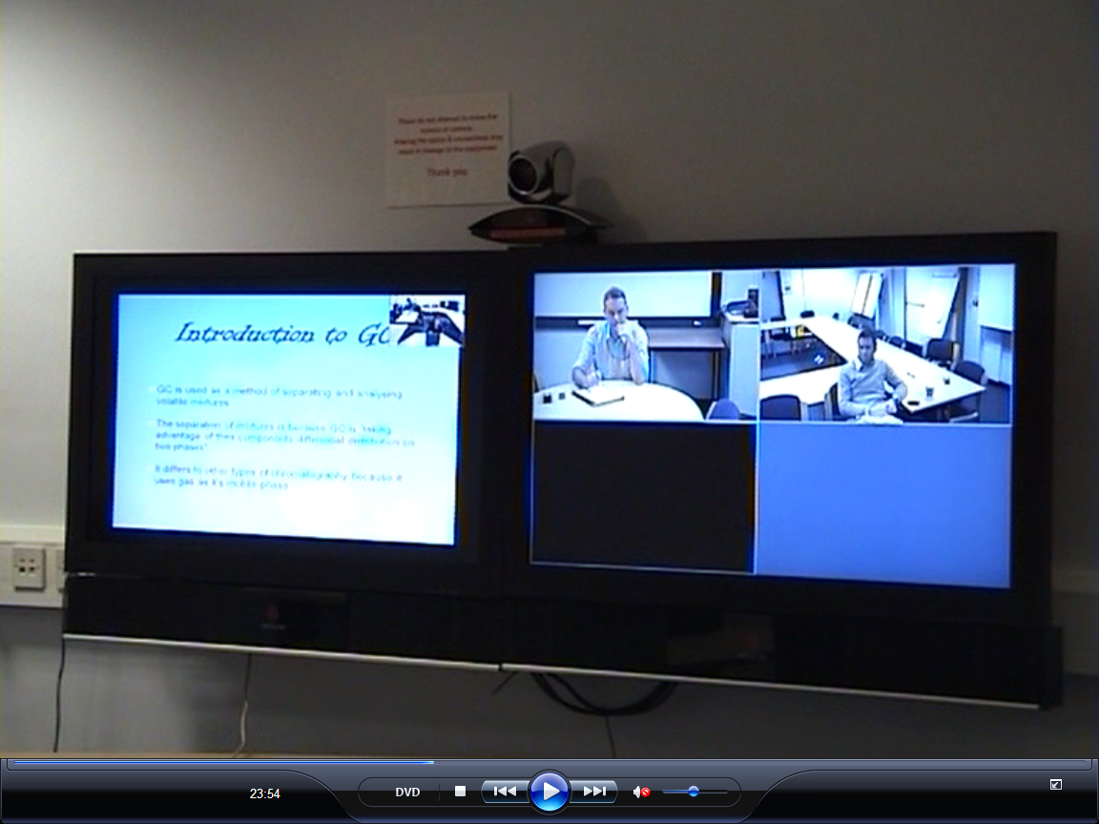
Figure 1: The VCON system during the presentations. The left-hand screen shows the PowerPoint presentation and thumbnail image of the presenter, the right-hand screen shows the participating employers (the black quarter denotes a telephone link to the third employer) and the camera is above the join of the two screens.

FlashMeeting (Figure 2) is vulnerable to online connection failures and limitations to the available bandwidth. As a result, the video quality images of those taking part can freeze or ‘jump’ (i.e. freeze momentarily). The student presentations were all prepared using Microsoft PowerPoint and each slide required uploading as separate picture images. The clarity of text was sometimes lost although most diagrams and pictures contained within the slides were clear. However, the audio quality was satisfactory for the presentations and a useful text chat function which allowed continued communication if the audio or visual elements failed or to help communication at startup should issues with the audio settings or webcam arise. FlashMeeting was accessed by one employer via a smartphone, and this facility combined with improvements to broadband and mobile networks and the adoption of tablet technology with clearer screens may result in this technology becoming increasingly viable.

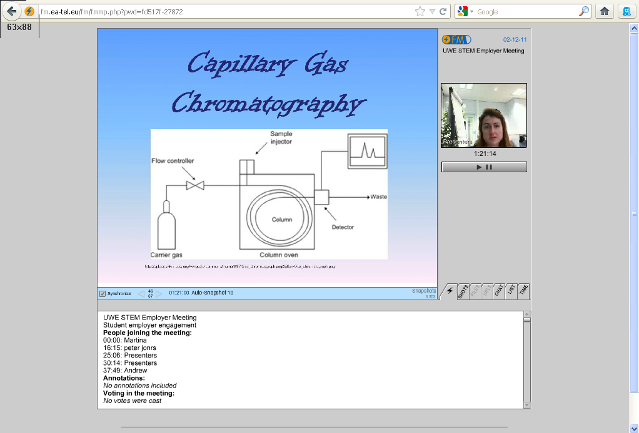
Figure 2: Screenshot of a FlashMeeting playback illustrating the thumbnail image of the presenter and PowerPoint presentation.

The opinions and experience of the three groups involved (presenting students, non-presenting students and employers) were collated and summarised below.

Feedback from the presenting students was entirely positive. Despite the challenge of producing and delivering the presentation to professionals for the first time, the students appreciated the opportunity to improve their skills and gain direct feedback from employers. The student presentations were of a very high standard and eminently suitable for the project. Very little input from the academic staff was required with their design or composition despite the students’ lack of presenting experience. As such, the appreciation and compliments about the presentation by the employers resulted in it becoming an important confidence building exercise which helped the students be aware that their presentation skills were of a high standard and that the techniques that they were presenting were of high importance to employers. Academic staff often have difficulty effectively communicating the importance of analytical techniques to students, however employers describing their reliance on the techniques resulted in the students appreciating the relevance of their skills. This helped to emphasise that analytical techniques which can be difficult to learn are essential and helped provide validity to the course content.

The feedback from non-presenting students (i.e. those who completed the assessment based on the recordings of the presentations) tended to be negative. 32 of the 61 non-presenting students replied with negative comments when surveyed at the completion of the IAS course. A number of causes were identified for the negative outlook on the project:
- A negative feeling was caused by the impression that it constituted an extra assessment rather than a component of the same assessment
- The students had little or no previous experience of this type of interpretation and they felt outside of their comfort zone completing the assignment
- The timing of the presentation coincided with assessments for other causes and the students felt the not enough time was given to complete the assessment.
- The comments made by the employers were not relevant to all practical exercises undertaken, and often focussed on specific feedback to the presenting students rather than providing new information for the benefit of all students.

The combination of these factors gave rise to concern that the assessment was likely to cause a significant reduction in grades for the practical write-up. Without any previous experience of the assessment it was difficult to remove these concerns. In fact, after the completion of the assessments the average mark for the presentation-based assessment was 61%, identical to the average 61% mark given for the practical write-up component (despite the marking of the two sections being independent and marked simultaneously). Interestingly 12.5% of the assessments were based on analytical techniques not covered by the presentations, but these students attempted to relate the feedback from the employers to the additional techniques. An additional 8% of students attempted to include multiple techniques in their assessment. Despite this, there was little evidence that these different strategies used by the students were detrimental to their overall mark.

The assessment was the same for all students, whether they had presented or not. All the presenting students discussed the technique they had given their presentation on and had no concerns. Students could choose one of four techniques/practicals to write up, and it was interesting to note that some chose techniques not covered in the presentations. They therefore had no direct support from this exercise to their task of writing about the relevance of that technique. The conclusion is that the assessment task was successful overall, but would be improved by employers giving more direct information about the relevance of each technique in their company.

The feedback from the participating employers was very positive about the presentations and the students involved. All five employers recognised that the use of this type of technology will probably be inevitable in the near future and will therefore have to be adopted. The employers appreciated the high standard of the technical aspects of the presentations and the standard of the presentation skills of the students. They appreciated that the presentations were a useful and appropriate method to view the students in terms of potential further involvement, for example, placements, internships and ultimately employment. The presentations also improved the level of employer interest in the course which will help raise the profile of the course and benefit all the students on the course. All the representatives involved in the presentations expressed that they would like to continue their involvement in subsequent years.

Discussion, Learning and Impact:
The use of both technologies proved appropriate and successful for the purpose of enabling employer-student engagement. The process of designing and implementing protocols for the presentations and in encouraging employer engagement has allowed the development of important contacts with organisations and employers. For example, the involvement and support of the Royal Society of Chemistry (RSC) was essential to initiate contact with a number of employers. The involvement of the RSC was important in this first year to enhance credibility of the project.

The project has been a valuable learning experience and highlighted the following important changes and areas of attention that are to be addressed for future years:

- The timing of the presentations has to be sensitive to the overall academic demands on the student workload and on the most appropriate time for company involvement. Employers and students proposed that the presentations would be more appropriate in the spring after the completion of the academic practical course and before the most popular times for company representatives to start taking annual leave.
- It is advisable to improve the preparation of company representatives in the nature of the feedback given following the presentations. It is important that employers clearly discuss the importance of the techniques described to their sector rather than concentrating on detailed technical issues.
- Improved information should be supplied to the students in subsequent years of the potential benefits of presenting. The experiences of the students during this first year of the employer-engagement will provide extremely valuable feedback to help inspire further years and it is hoped the participating students will be involved in this process.

Further Development and Sustainability

Will the activity continue in the future?
(a) Yes (in its current form) (b) Yes (in a modified form) (c) No/Unsure

If you answered (a), how has this sustainability been achieved and in particular how have you enabled the activity to continue without HE STEM funding or direct support?

If you answered (b), how will the continuing activity differ, for example, in its structure or delivery? How will the activity be sustainable and continue as a result of this modification?

If you answered (c), what has prevented the activity from becoming sustainable? What will now happen to the activity?

If you answered ‘unsure’, upon what does sustainability depend?

(b) Yes (in a modified form)
The format of the presentations and assessment task will remain essentially the same in future years. In terms of the technology, it is probable that VCON will be used unless sufficient employers do not have access to the technology, in which case FlashMeeting can be used as an alternative. The main modification to the engagement will be to make the presentations part of the students’ Graduate Development Programme (GDP) rather than integrated into the IAS course. This will link the presentations directly with discussion of future employability and will remove their perception of the assessment as an extra assessment on the IAS course. The project is being extended to include other areas of science, in particular DNA analysis, which would then provide links between employers and students taking genetics modules at level 2. Incorporating the exercise in GDP removes timetabling constraints linked to a specific module and will allow more flexibility to timetable presentations at the most appropriate time for both students and employers.

Additional funding would enable resources to be prepared that could be easily adopted by other staff at UWE as part of the Graduate Development Programme in other subject areas (eg Environmental Science, Engineering and Maths). It would be important to run staff development sessions to raise awareness and support such implementation. The Department of Applied Sciences at UWE has indicated that it is supportive of this extremely beneficial activity and intends to allocate a modest resource each year to enabling it to continue and develop. This will help contribute to the future employability of the undergraduates and provide significant benefits to students and the university. These changes and developments will ensure that the activity can be sustained, especially as relationships with employers are developed.

In relation to the approaches to sustainability outlined below, we are very interested in activities and commitments which have occurred within the timescale of the project. However, we recognise that some approaches may still be in the development phase at the official project end date and it would also be valuable to include these examples in the template.
Approaches to Sustainability | Examples | In relation to your project
Continuance (finding alternative sources of funding) | Commitment from institutions to provide continuation funding  - Network/ communities likely to be sustained through inclusion in future funding bids | The Department of Applied Sciences at UWE has indicated that it will support the provision of staff time to enable the continuation of the engagement in 2012-2013.  The employer contacts will be sustained to enable this.  Networks with the Get STEM working partners are also to be maintained for potential future funding bids.
Embedding (within institutional activity) | - Identification of institutional strategies that the project has informed  - Uptake which has taken place, or is likely to take place, within own/other HEIs  - Influencing of organisations external to HE Sector which has occurred through partnership working | Employability is a key strategy of the university and this project addresses this issue.  The engagement will remain for Forensic Science students at UWE. Other universities have expressed interest in the use of the technology.  External organisations such as the RSC and employers have appreciated the demand and value of the employer-engagement using technology.  The remit has been extended to include biological sciences, in particular DNA analysis, which will require establishing links with a further set of employers.  Additional funding would enable the development of a resource that could be easily adopted by other staff at UWE as part of the Graduate Development Programme which has a focus on employability at level 2
Mainstreaming (changes in working practices) | - Staff development which is planned or has taken place as a result of your project  - Curriculum enhancement that has occurred or is likely to take place as a result of your project  - Influence of senior managers that has arisen as a result of the project | The importance of employer-engagement has resulted in a commitment to include it in subsequent years, probably as part of GDP.  The benefit to the students, employers and the university have been demonstrated to senior managers in the faculty resulting in the commitment to some staff time resource.  Additional funding would enable:  running information and training events for staff to encourage and support adoption of this form of employer/student engagement using videoconferencing and/or online meeting technology
Legacy (passing on important elements of the project) | - Networks/communities likely to be continued  - Dissemination of project outputs  - Evidence of impact of activities  - Creative Learning Journey material made available via the SW Spoke Creative STEM website where relevant. | The employer contact will be maintained. It is hoped potential collaboration may be developed with other HEIs in the south-west.  Project outputs have been disseminated through a variety of internal and external presentations and reports.  The impact of the activity is evidenced by the desire by the university and employers to continue the employer-engagement in subsequent years.

References:
R. Canning (2002). Distance or Dis-stancing Education? A case study in technology-based learning. Journal of Further and Higher Education 26(1); 29-42.

K. Galen Kroeck and K. O. Magnusen (1997). Employer and job candidate reactions to videoconference job interviewing. International Journal of Selection and Assessment 5(2); 137–142.

G. T. Sherron and J. V. Boettcher (1997). Distance learning:The shift to interactivity. CAUSE Professional Paper Series, #17 (Boulder, USA).

J. Sokoloff (2012). Information literacy in the workplace: Employer expectations. Journal of Business & Finance Librarianship 17(1); 1-17.

Quotes:
Below are just a few quotes from the participants illustrating some of the experiences:
“This is inevitably going to be the future of contact between employers and students for graduate employment” (Employer 1).
“The videoconferencing system is a much simpler and better quality system than I had expected; a pleasant surprise” (Employer 2).
“This exercise provided insight into the capabilities of the students with all the benefits of the technology platform” (Employer 3).“Presenting was a really valuable experience....and much less threatening than if the employers were in the room” (Student 1).
“Apart from being nervous to start with, this was such an easy way to talk to the professionals” (Student 2).
“It’s such a good thing to be able to talk to someone who has the job you want to do in the future” (Student 3).

