Developing a Better Understanding of Key Drivers for Effective Employer Engagement through an Innovative Approach to Relationship Management

The college has a dedicated team of staff (Directorate of Employers) responsible for the implementation and achievement of our employer engagement strategy but one of the key objectives of this project was to more effectively share the practice of this team amongst other teams within the organisation to include those within the School of Business, Manufacturing and Transport. Higher Level Engineering courses are in the main facilitated by colleagues within this School. The further aim was then to share organisational best practice with colleagues from HEIs’ and colleagues within the FE and Skills Sector within the South West region as Petroc is the South West Regional STEM Centre.
College Vision: To be an outstanding college at the heart of an outstanding learning community

College Mission: To drive forward educational, economic and cultural success by continually raising the aspirations, knowledge and skills of individuals, communities and businesses

The HE STEM project was clearly focused on developing a better understanding of relationship management throughout the organisation so that we could further develop our practices and consequently achieve the aim of meeting the skills needs of the people, communities and employers of the region. The college is committed to working in partnership with others to engage employers to meet their current and future skills and professional needs.

Project Key Objectives:-
To further develop the dedicated employer interface:-CRM (Customer Relationship Management resource) so that our systems operations are flexible and responsive to the needs of business.
To use the CRM to review the extent of STEM industry employer engagement in terms of Engineering
To further develop a resource that will be of use to colleagues directly involved with employer engagement allowing them to identify current and future business needs of employers. The Organisational Needs Analysis resource will allow the identification of employer training needs (Bespoke CPD identification) whilst allowing the development of business solution plans.
To develop a system of enrolment that is understood by all staff directly concerned with employer engagement (staff within the Directorate of Employers and those within other Schools of the organisation) which acts as an ‘engager’ rather than a barrier to usage or participation.
To develop our ability as an organisation to provide information, advice and guidance for employers to allow them to understand the wide range of courses, qualifications, training and support programmes available to them so that they can make informed decisions with regards to their specific needs to facilitate workforce development and effective succession planning.
To develop the ability of staff within the organisation to develop their skills in terms of harnessing technology to improve the quality of teaching and learning being delivered and also to allow further development of the colleges’ virtual learning environment for each programme delivered so that employer learners have the opportunity to update their knowledge and skills through blended learning. This CPD was made available to both Higher Education and Further Education colleagues and in addition a bite size session was facilitated at the LSIS South West STEM Conference to extend’ reach’ and participation.
To develop a number of on line resources to enable staff to undertake CPD flexibly that addresses effective employer engagement: CRM Guide, Case Studies of effective practice, ONA Guide.

Employer Engagement at Petroc
As an organisation our employer engagement activity has developed over successive years. Initially, individual academic Departments (now named Schools), initiated their own separate response to perceived employer needs. This need grew from sector focus groups and employer presence on National Diploma and early Apprenticeship Steering Committees. Departments also responded to the early government FEFC and LSC ‘steers’ regarding future government funding priorities. The individual Department employer response and market analysis activity was deemed to be uncoordinated and inefficient. This evaluation lead to the Senior Management Team of the organisation instigating a central reorganization and restructure leading to the creation of a central Employer Directorate. Having this Directorate now enables us to further develop and implement our Employer Engagement Strategy to facilitate the effective collection, collation, analysis and evaluation of market information.
The College has recently restructured and has created three Directorates:
- Directorate for Quality and Performance
- Directorate for Resources
- Directorate for Employers

Petroc Organisational Chart – Senior Management

The Directorate for Employers is responsible for implementing and achieving our Employer Engagement Strategy.
The staff within this Directorate are purely focused on responding to the needs of employers and this project has allowed the review and modification of resources used by this team to improve efficiency and effectiveness whilst facilitating the sharing of best practice with colleagues within other areas of the college who provide engineering focused professional development. The use and value of using the Customer Relationship Management tool has also been shared with other internal colleagues and colleagues who have visited the college from HEIs as project partners wishing to share best practice and exchange ideas.
Devon generally, and in particular North Devon, is essentially rural. Within this context the economic profile of the North Devon area is dominated by small, medium enterprises (SMEs) and micro-businesses.
This rural isolation together with the predominance of small/micro businesses, has driven our success with employer engagement programmes.
Our programmes have not relied on employers coming to us for day release courses, or sending their employees on a long and time consuming journey to College. Instead, we have responded to the above market by providing courses that are delivered wholly in the workplace. The more of these programmes we offered, the greater their uptake and enrolment occurred. These types of courses quickly enrolled more learners than their day release counterparts, to the extent that our current very high volume of work based programmes is compelling evidence that employers much prefer our methods of employer engagement, compared to the static numbers of traditional day release courses.
Small businesses in the South West rarely have the capacity to employ staff with high levels of expertise or to train staff internally, and access to support and advice services is limited due to rural isolation.
It is within this rural and Micro/SME context that our work-based training programmes have been developed, and our model of employer engagement has evolved.
The current economic climate demands that all staff within all Schools look to engage employers more effectively to generate income for the organisation to sustain the workforce . It is therefore a strategic priority of the organisation to improve our employer engagement and to make more teams within the college aware of the CRM and the potential benefits of engaging with its use.

Customer Relationship Management
Our College manages closely all aspects of the relationship between the employer, the College and partners to ensure that the customer gets the product they need in a timely, efficient and professional manner.
We achieve this by:
- Providing customer care development/training for all relevant College staff
- Co-ordinating all contact, advice and discussion with employers to ensure prompt and appropriate responses
- Developing and maintain a customer database of contact, skill needs, previous provision, etc.
- Reviewing quality of provision- Gathering employer feedback from Marketing and Telesales activity, and feeding this in to our quality improvement and assurance processes.

Employer Experience
Our College has developed an employer experience which is comparable with the very best the private sector can provide.
Our delivery of education and training is characterised by its minimum intrusion into business operation.
We achieve this by:
- Articulating and implementing the Petroc employer experience
- Developing teaching and learning strategies which maximise success whilst minimising disruption
- Developing the teaching and learning staff to have the appropriate skill set to deliver to employers

Skills
Our College in partnership with others, plays an essential role in meeting the Skills needs of industry throughout the South West.
We achieve this by:

- Providing high level representation for key local and regional, sectoral partnerships in order to promote the skills needs of local Industry.
- Working in partnership with Sector Skills Councils to develop regional, national and local plans for addressing skill needs
- Establishing focused project teams to meet particular skill needs which will draw upon expert staff, innovation and best practice

Create Demand for Leading Edge Skills and Practice
We stimulate and challenge employers to embrace leading edge skills and practices thereby adding value to the products and services they provide.
We achieve this by:
- Communicating our services through highly focused marketing methods and techniques
- Delivering innovative training in innovative ways
- Developing more employer focused higher education programmes
- Embracing enterprise and innovation throughout the College
- Leading by example in the services and facilities we provide

Curriculum
The College continually develops its learning products to meet the aspirational and skills needs of our learners, employers and other stakeholders. Our Curriculum will appropriately embrace emerging learning models and frameworks in meeting needs but will neither be constrained by nor driven by these models.
The College develops, in partnership with others, a comprehensive, broad, seamless curriculum in a flexible and responsive manner, maximising and developing the use of high quality learning resources.
We achieve this by:
- Mapping and expressing our employer based curriculum in terms of skills, learner participation, achievement and progression
- Developing high quality learning products to meet the skills needs of employers, not just specific qualifications
- If we cannot meet the skills needs of an employer, we should seek the provider who can
- Providing a curriculum that will recognise the benefits to be gained from a unitised multiple entry point approach to curriculum development and delivery
- Developing a curriculum that maximises the effective use of ILT and other high quality learning resources

Customer Relationship Management (CRM)
The aim of the CRM is to:
- Provide a sole point of entry for any employer enquiry in whatever form
- Ensure that this enquiry reaches the correct person(s) for resolution
- Track, record, and monitor all such enquiries
- Provide a vehicle for multiple strand enquiries

The CRM tracks the customer’s journey from initial enquiry stage to enrolment stage. This includes internal and external referrals, and a record is made of the status of the enquiry at any point. Automatic emails to people are generated as “actions” which are logged and monitored for timely response(48 Hours)
An integral part of the CRM system is the organisational database. This database lists all the companies we have been in contact with over a 4 year period, regardless of whether we have engaged with the company or not. The organisational database supports the CRM system as well as our Health and Safety monitoring process to ensure that the relevant checks are in place for each company we work with. The organisational database also records information on company contacts, size, sector and the number of students who have undertaken training.
The College’s restructure has created a more employer-focused approach, and a team of CBDMs and Heads of Schools have been engaged, whose responsibility includes managing the relevant curriculum area and companies on the CRM.
They are responsible for ensuring enquiries are dealt with in line with the College’s service standards which were reviewed and amended following the restructure.
We have a set of customer service standards for each team within the Directorate. These standards cover the whole customer journey – from enquiry to achievement of qualification and business impact, and are internally monitored and reviewed on a regular basis by the relevant Team Leader.
Our customer service standards are underpinned by key principles:
- Customer Relationships
- Success Measures
- Employer Engagement
- The Employer Experience
- Meeting the Skills Needs of Industry
- Creating a demand for Leading Edge Skills and Practice
- Curriculum Development

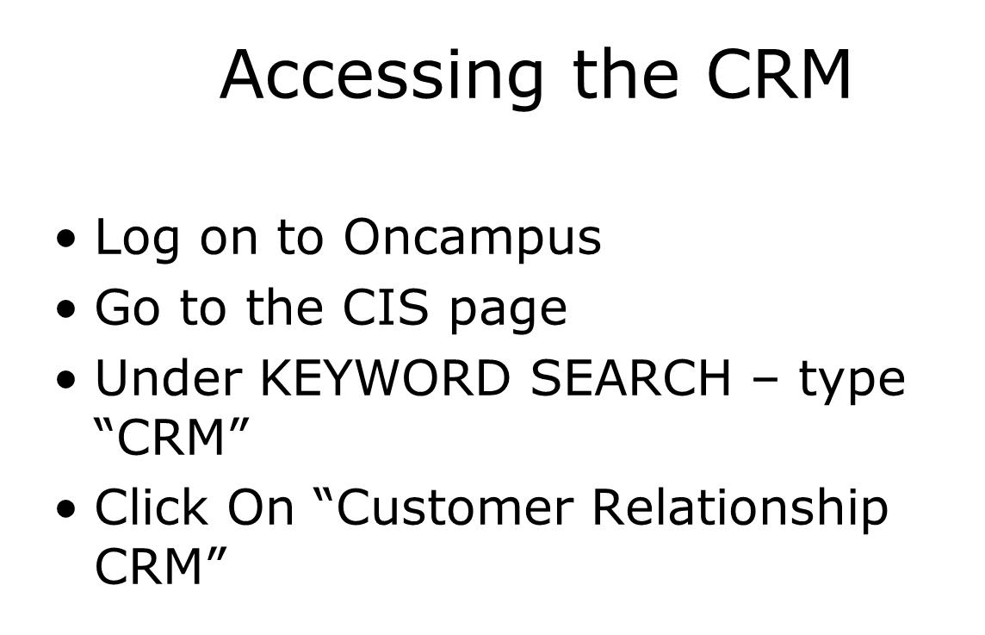

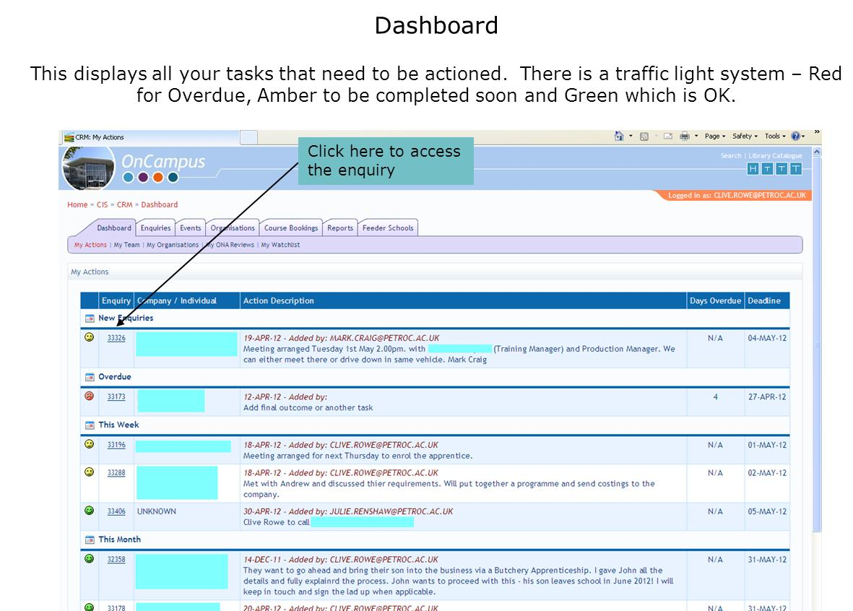
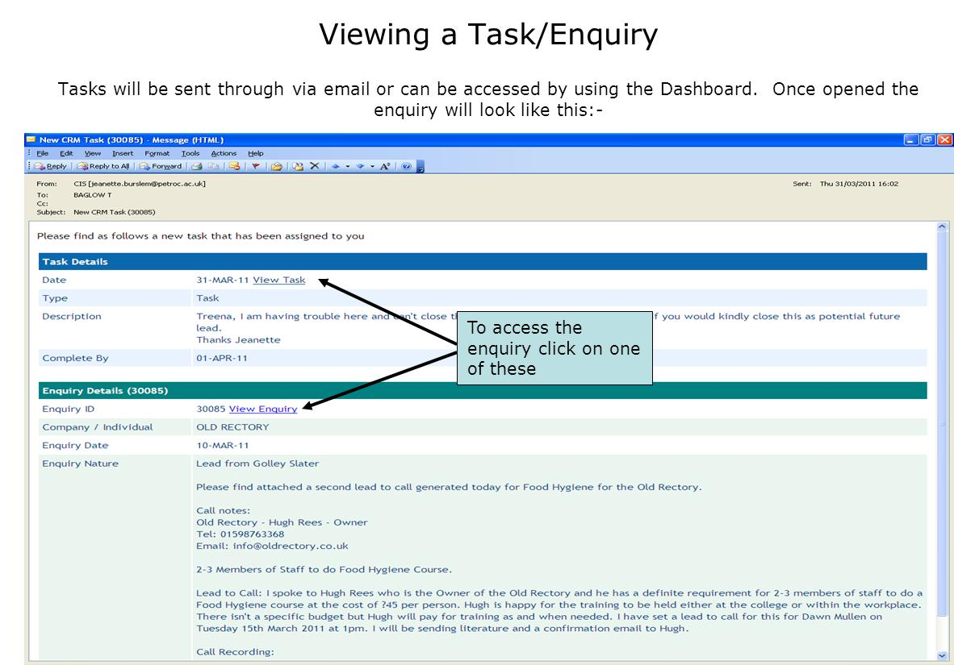

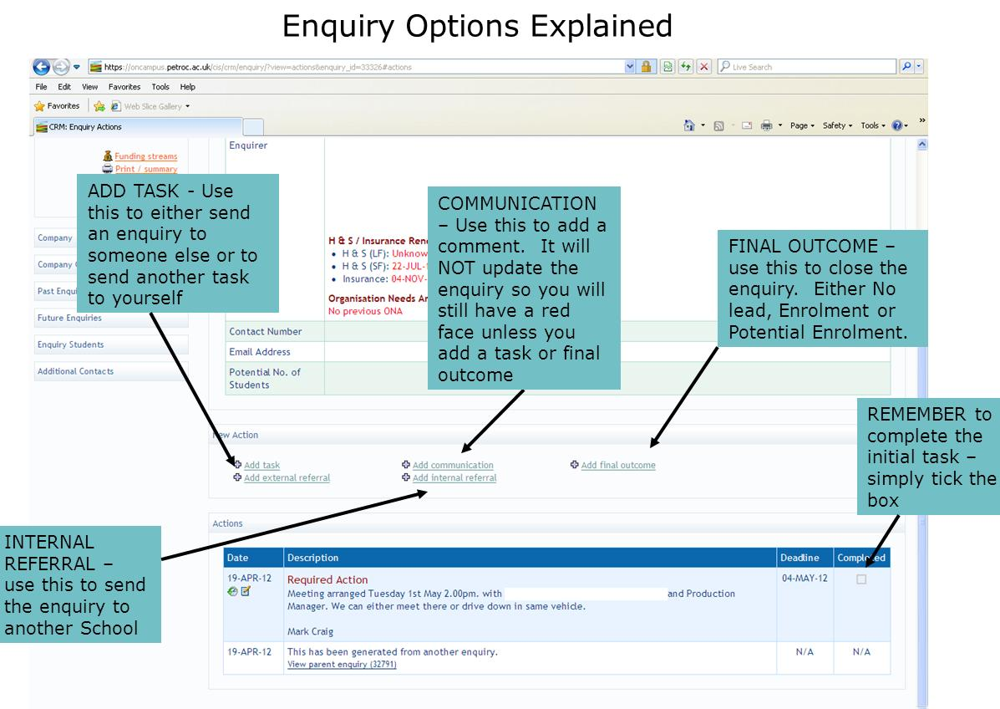

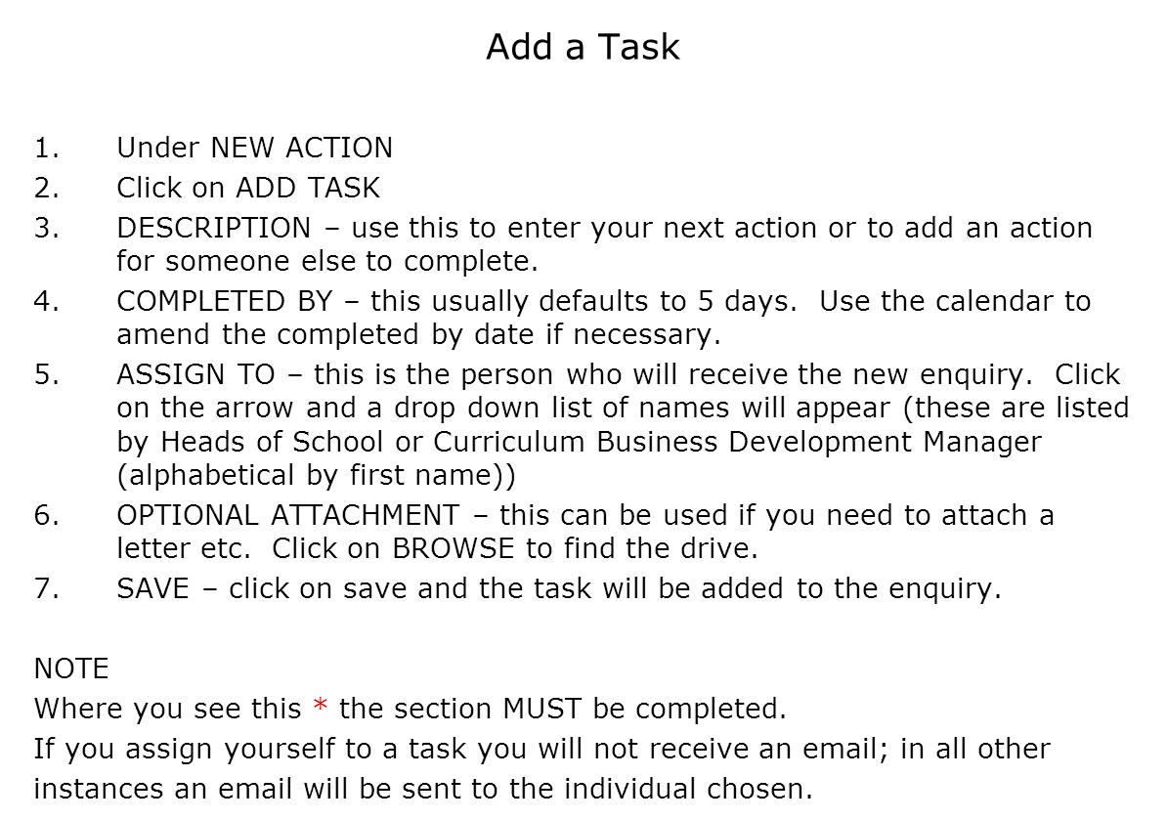

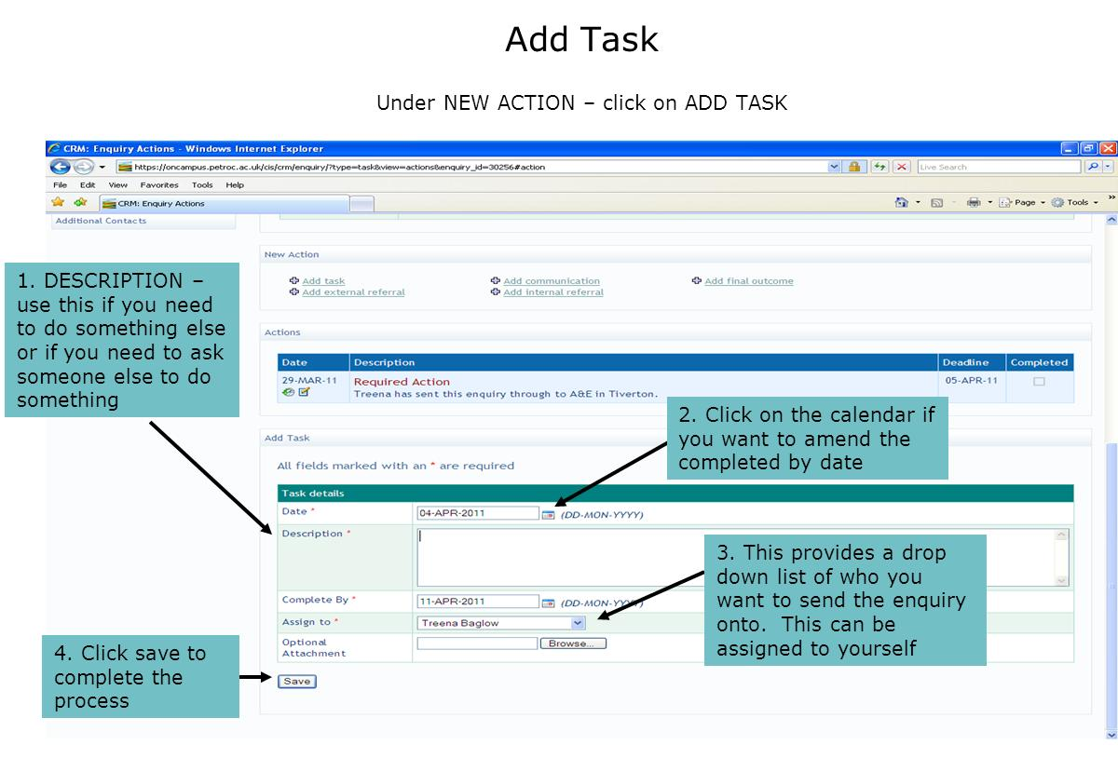

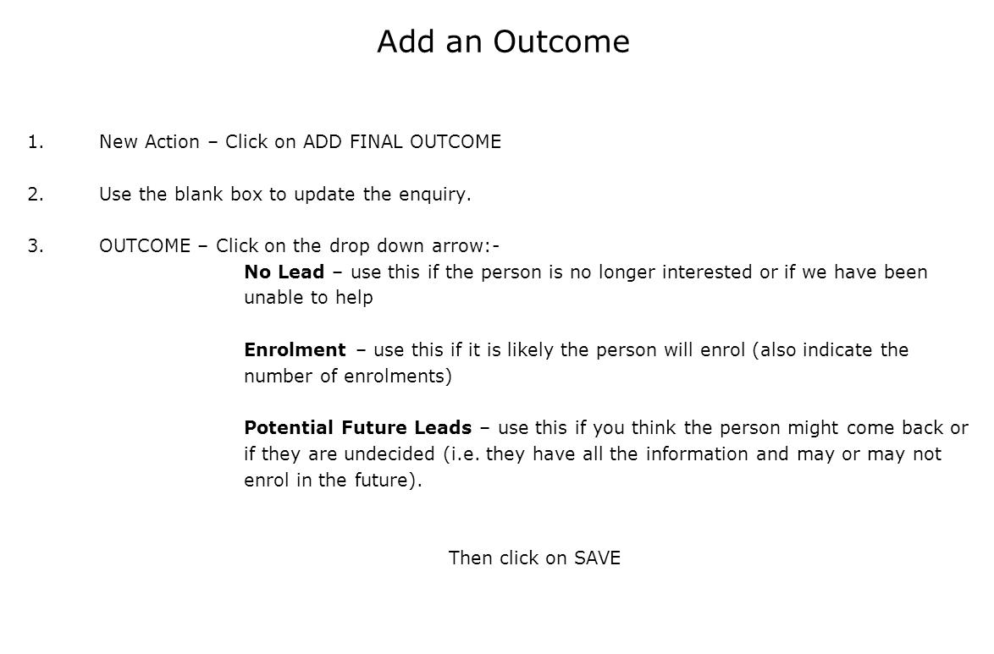

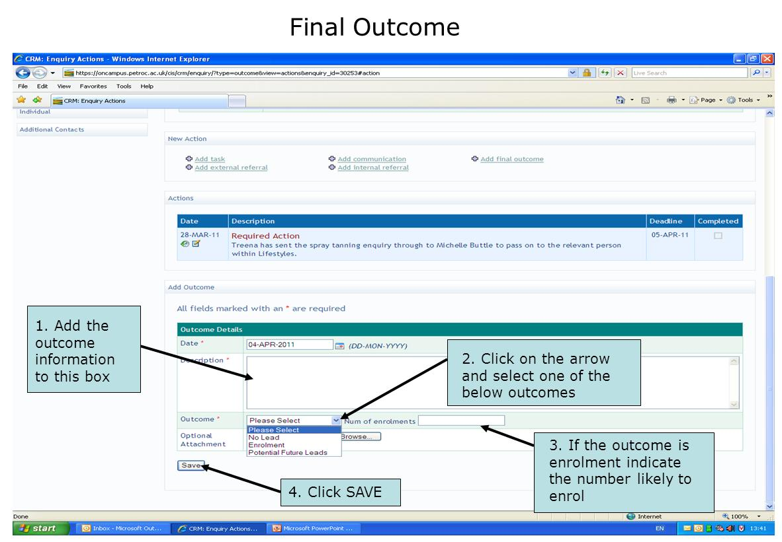

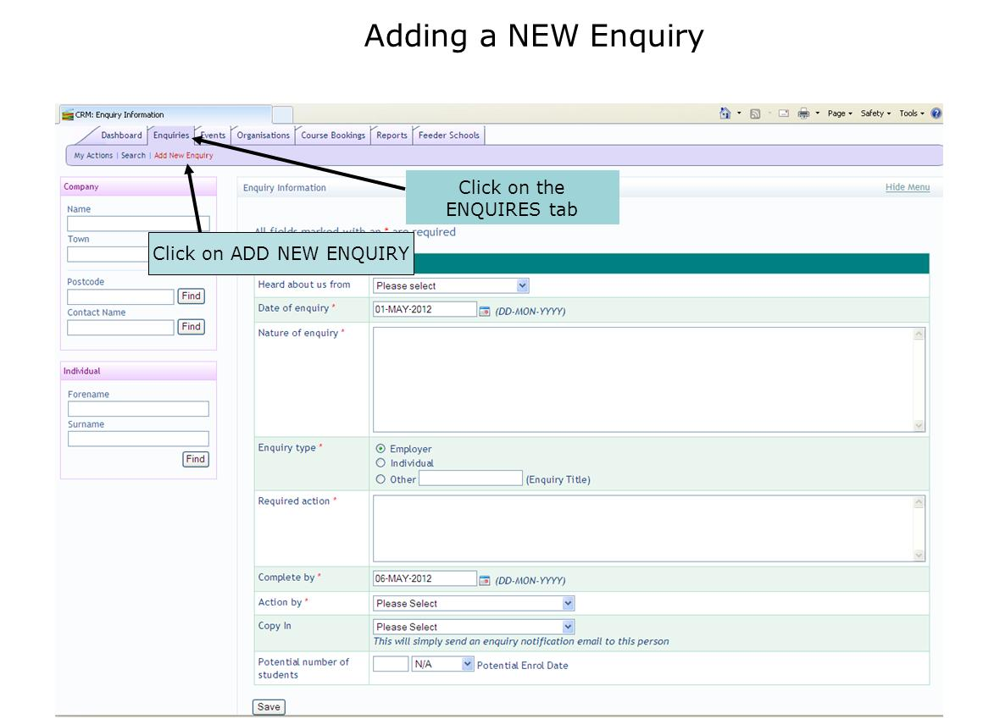

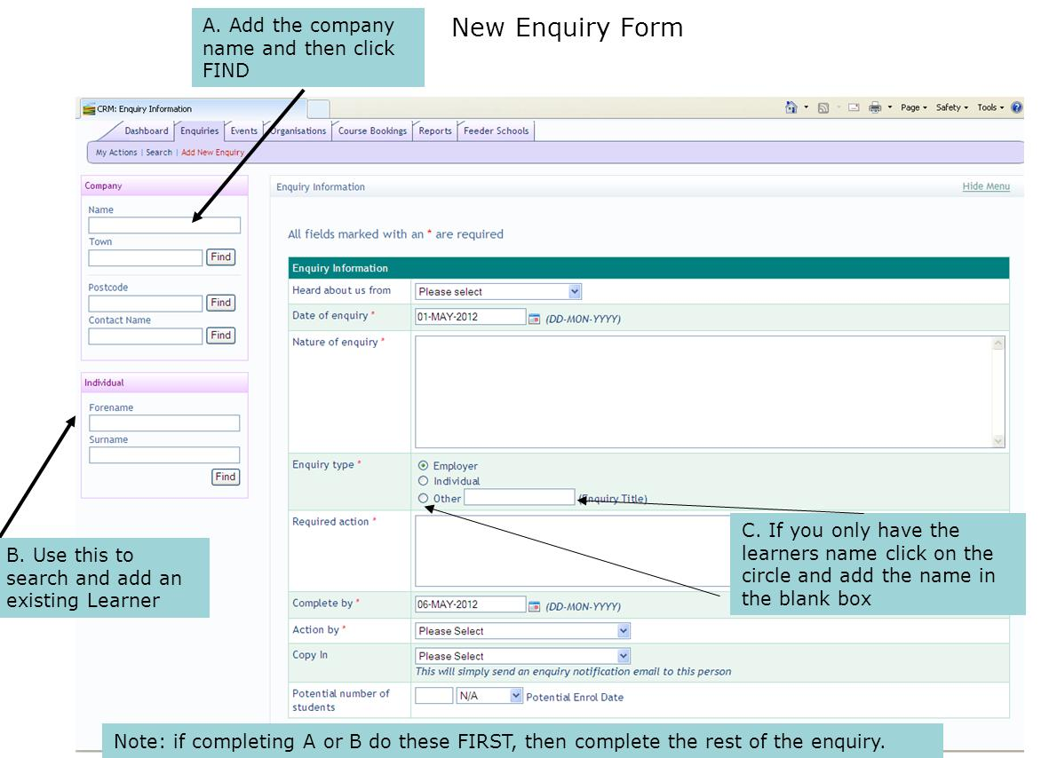

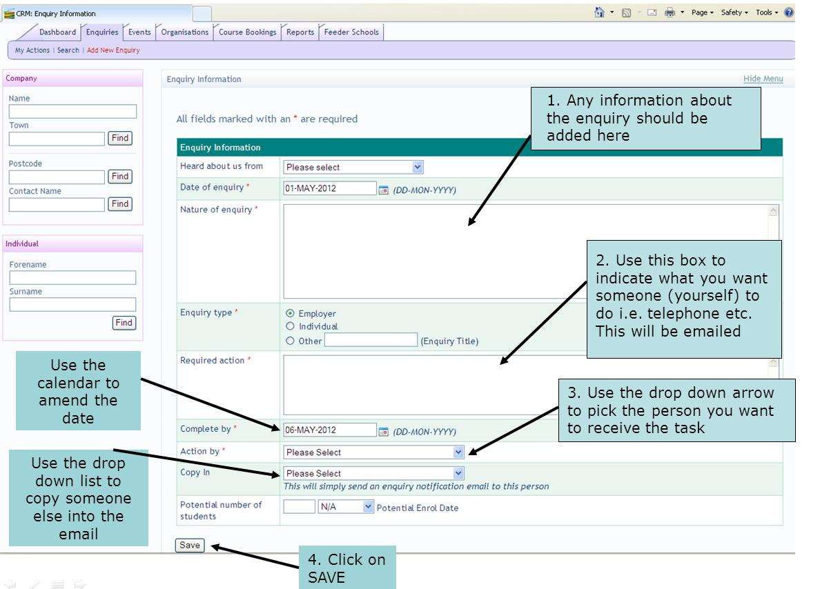

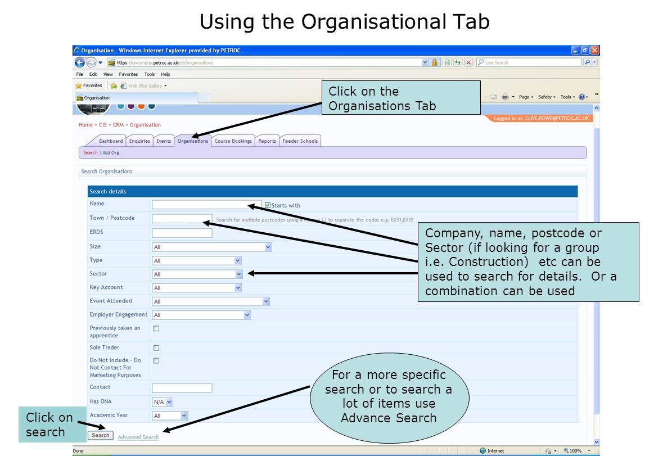

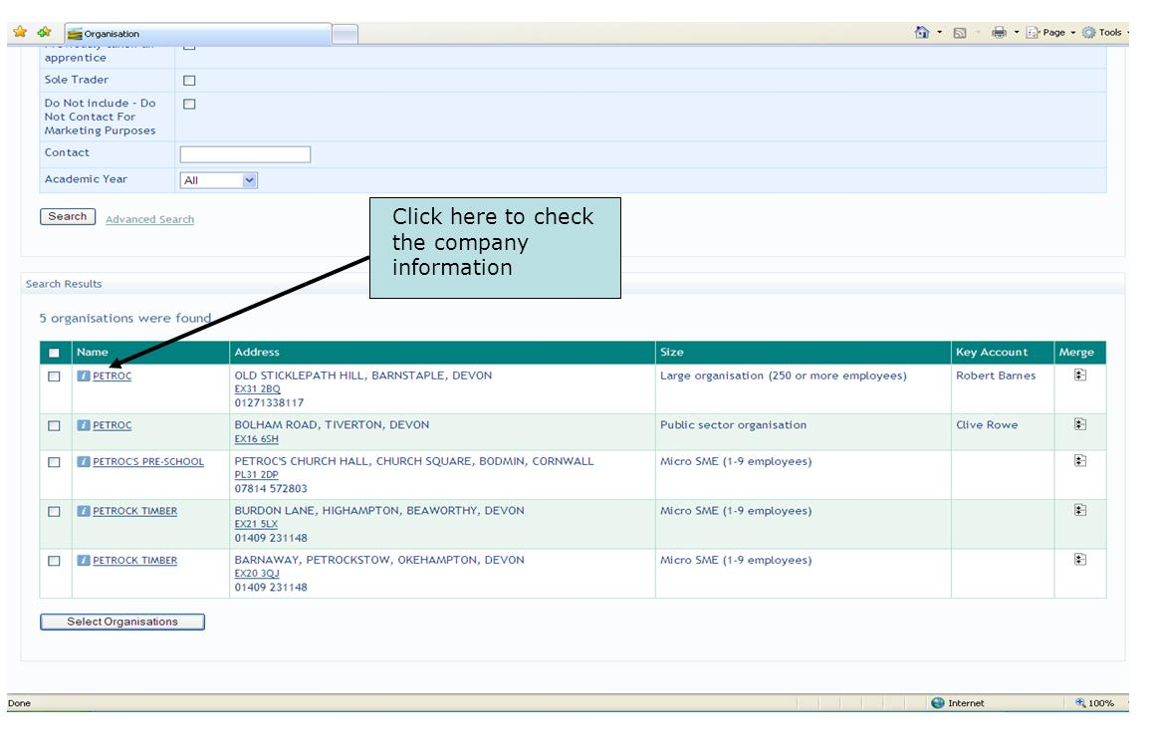

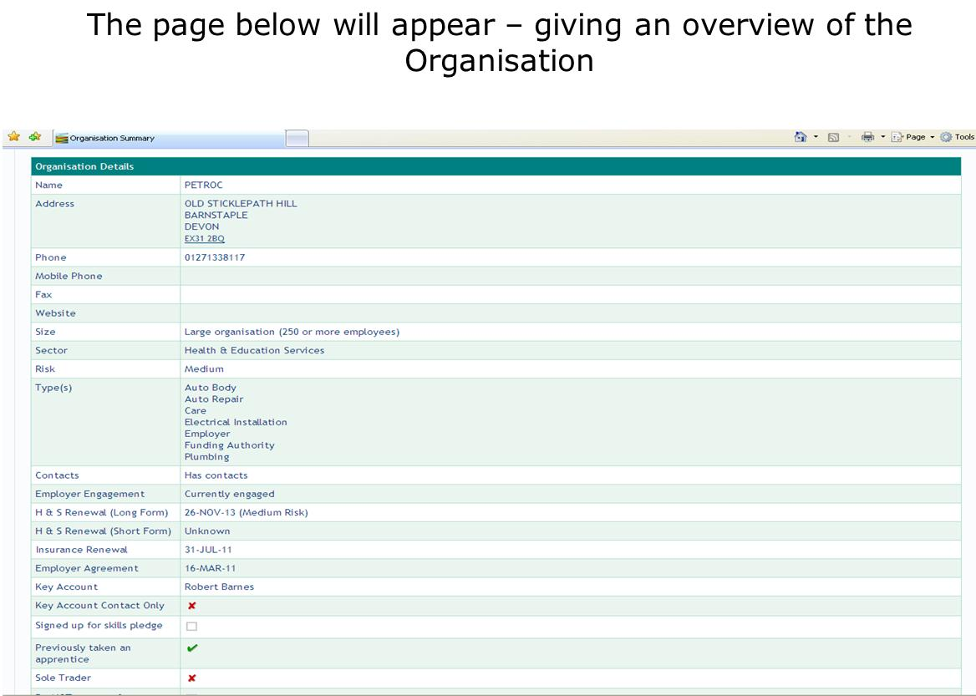

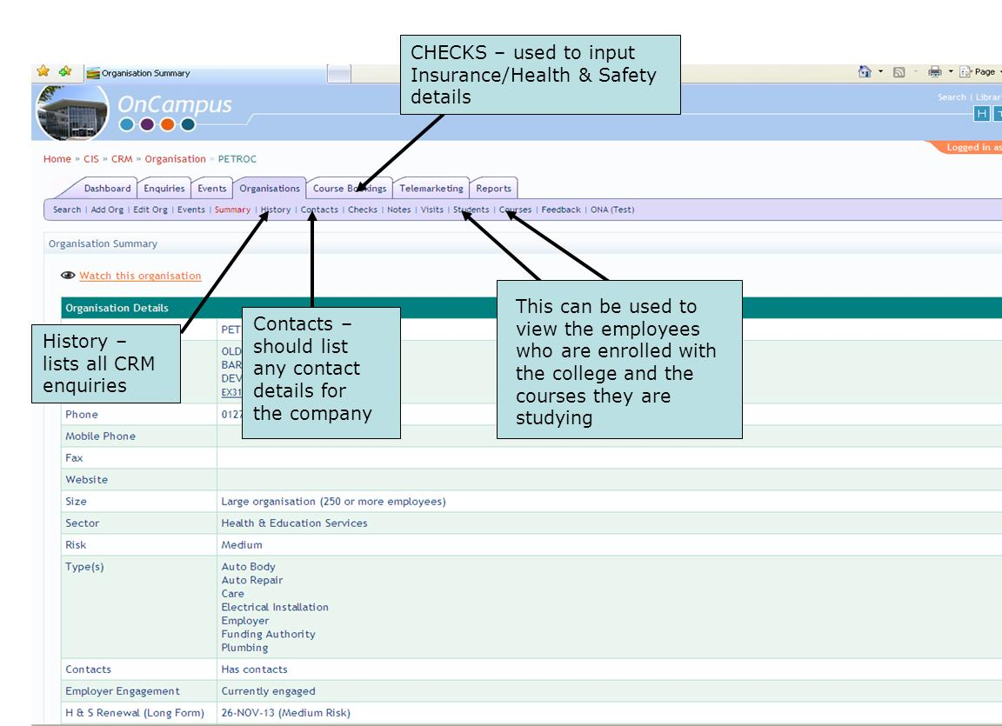

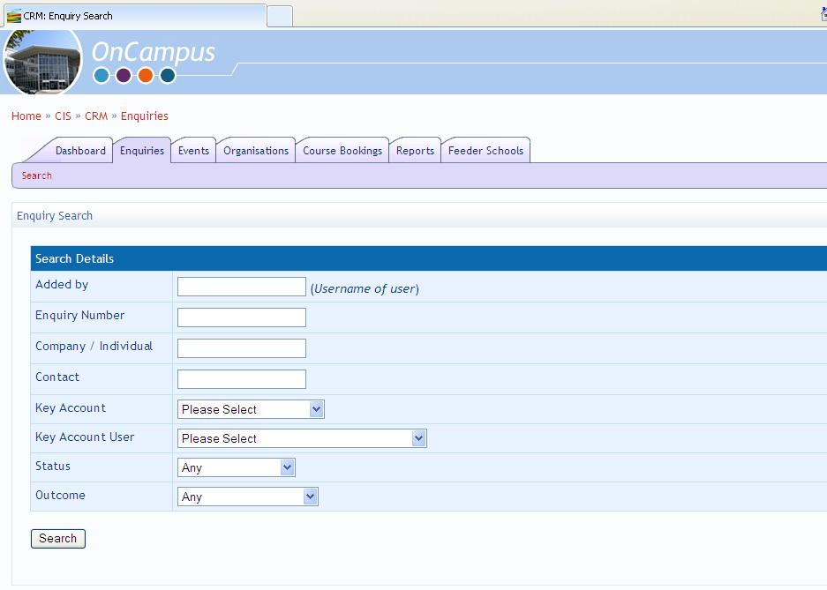

Examples of monitoring include:

- Monthly meetings with the Learner Services Centre, Tiverton Hub, Reception Staff and Short Course Team
- Mystery Shopper
- Monthly quality performance statistical monitoring
- Weekly overdue CRM enquiry position
- Employer feedback
- Administrative accuracy reporting
- Observations(including peer)
- Costing reviews and budget monitoring
- Monthly team meetings (including Marketing meetings)
- Internal and external audits and EV visits

Enquiries

All enquiries are logged centrally and processed using an in-house C.R.M.
Larger companies have a key account manager assigned to them (identified on the CRM) who is also copied in.
The nominated curriculum expert and key account manager will work together in their response to the enquiry from the larger companies.
Key Account Managers have a clearly defined job role and skills and experience requirement in their job specification.
Within the Schools nominated experts are identified by the relevant Head of School, details of which are shown in the Organisation Chart
New enquiries and initiatives are an agenda item at each fortnightly Directorate for Employer Management Team meeting:
The College receives enquiries via the following routes:
- Guidance Centre
- Website Enquiry
- DfE Curriculum Teams
- Employer Services Teams
- Sales and Marketing Team
- Schools

All enquiries are uploaded on to the system by the Employer Services Team, CBDM or Business Solutions Advisor. Members of the teams also undertake the Organisation Needs Analysis (ONA) for the relevant company if not already in place. The targets set in the ONA are reviewed to establish their impact on the business. The CRM system is undergoing constant improvement as we evaluate its effectiveness, and we are currently working with our CIS team to introduce an automatic alert to our Telemarketing Co-ordinator when the review is required to be undertaken.
The College’s website has an employer’s page which has a facility for the employer or individual to send an enquiry via email direct to the College’s CRM system. This system is checked daily by the Employer Services Team Leader in order to ensure enquiries are dealt with efficiently and effectively.
If an enquiry is received for a company with a variety of needs then this type of enquiry would initially be directed to our Business Solutions Advisor. The College’s Business Solutions Advisor role is primarily to co-ordinate multi-vocational training solutions.
If the enquiry has been received for one of the curriculum areas then the Business Solutions Advisor or Employer Services Team would refer the enquiry to the relevant manager. They would drive and manage this enquiry themselves or nominate an expert within their team..
As we are one of the largest training providers in the South West we are able to provide a solution for most training requirements requested by employers. Where we are unable to offer the training solution this enquiry is sent electronically via the External Referral system within the CRM. The CRM system emails the enquiry directly to the nominated Training Provider and our Employer Services Team Leader monitors the enquiry to ensure that this referral has been actioned, and that the customer’s needs are being addressed:
The College offers a number of marketing events throughout the year and there is an opportunity to record on the CRM which companies attend the event for future marketing opportunities. This facility is still under development. Sections within the Employer Directorate also hold events such as the Employer Forum for Care; this enables employers to network and share good practice. Guest speakers are frequently invited to participate in these events.
There are a number of reports set up within the CRM to enable us to manage information appropriately. The following reports in particularly are used regularly to monitor our management information:
- Marketing Report
- In-Progress Report
- Overdue Enquiries
- New Business – new companies engaging with each month
- Employer Feedback Results – provides data on satisfaction rates and comments
- Employer Feedback – monitors customer comments which require feedback. This list is checked on a weekly basis by the Telemarketing Co-ordinator
- Training Activity Summary Report – this report has been recently added and is still in the piloting stage. Its purpose is to highlight the employers where we are most active in delivering training.

The Telemarketing Co-ordinator undertakes weekly employer surveys over the phone for employers who have employees who have recently completed. Additional surveys also take place in line with the ONA targets or Framework for Excellence where applicable. The Telemarketing Co-ordinator will sometimes receive further comments from the survey which are sent to the relevant manager to action. The Telemarketing Co-ordinator monitors that these actions have been addressed in a timely manner. New enquiries are also generated via this means and these enquiries are generated via the CRM in the normal way.
Within the Employer Directorate the College has a team dedicated to the Short Course provision within the College. An online Short Course System is being developed to capture specific short course bookings to ensure that the CRM reflects the full employer picture. This will help to gather statistical information relating to demand for courses etc. If the employer is supporting the training then this booking is flagged to the Employer Services Team who undertake the ONA if not already in place. The targets set in the ONA are reviewed to establish their impact on the business and, as stated above, we are currently working on improvements to the CRM system which include an automatic alert to our Telemarketing Co-ordinator when the review is required to be undertaken.

Employer Enquiries

All enquiries are logged and processed using the PETROC C.R.M. (Customer Relationship Management Tool)
Reception
Guidance Centre
Employer Services
Sales and Marketing
Directorates/ Schools
Internal Referral to other Schools and Directorates
Employer Services or Short Course Team for actioning
Directorate for Employers
Website Enquiries
Internal Referral to Short Course Team unit.
Employer Services Team, Curriculum and Business Development Manager and Business Solutions Advisor. Input enquiry on to CRM and undertake Organisational Needs Analysis (ONA) if not already in place
Send enquiry to relevant Curriculum Business Development Manager or nominated member of team, who will arrange and facilitate training as identified on the Organisational Needs Analysis .

Quality Control and Assurance Once training has been completed Employer surveys are undertaken by Telemarketing Co-ordinator
Curriculum Business Development Managers / Telemarketing Co-ordinator – revisit the Organisational Needs Analysis to measure and assess business impact.
Page 19
Petroc - Organisational Needs Analysis by Petroc is licensed under a Creative Commons Attribution-NonCommercial-ShareAlike 2.0 UK: England & Wales License.
Based on a work at www.hestem-sw.org.uk.

