
Project Title: A partnership for engineering CPD, learning,training and knowledge exchange
Project Leader: Suzanne Maxwell, Head of CPD support & Development Office
Department CPD Office
Institution: University of Bath

Abstract:

The University of Bath has strong national and international links with industry. Its research grants and contracts portfolio is worth £87m and it runs one of the largest and most established placement schemes in UK higher education. The Careers Advisory Service has links with over 4,000 employers and a very strong employment profile with 89% of its 2010 graduates going straight into employment or further study.
Within the last few years, the University has been keen to develop Continuing Professional Development courses (i.e. courses for external professionals) which are responsive to employers’ and individuals’ needs, flexible in terms of delivery options and draw upon its research. However, statistics shows that this market is dominated largely by training providers (universities have a very low market share). This sub-project was part of a larger project undertaken at the University to gain a better understanding of the market and of the needs of employers.
The University recognised the potential strength a co-operative relationship (in this case with its partner colleges) could provide to employers in terms of the supply of knowledge and accredited learning and training across all levels from NVQ1 to PhD. In addition, by designing and linking curriculum and programmes associated with specific sectors (such as engineering) with other areas (such as business and management), it was felt that a co-operative approach may provide a range of attractive learning pathways to support workforce development. This project aimed to establish whether a market for this existed, with a view to exploring a longer term co-operative approach.

The University, in collaboration with three partners, Wiltshire College, Swindon College and the City of Bath, researched training and CPD amongst local employers in the engineering sector in the region with three main aims:
- To generate specific market information and intelligence about engineering employers’ training and CPD to understand more fully their behaviours and demands;
- To ascertain current levels of market penetration, overlaps and gaps in coverage by the University and Colleges;
- To develop innovative and co-operative working between the University and the colleges such that it can better meet the wide needs of employers and can lead to sustainable engagement across the region and between the four institutions.
Ultimately, the main objective is to develop lasting and sustainable relationships with companies to support them in developing their workforces and communities and thus help the regional economy to prosper and grow.
The University of Bath project, was one of six sub-projects making up an overall project led by the Marchmont Observatory, Progressing from labour market intelligence to HE level provision that is well supported by employers.

List of Outputs:
- A case study report that outlines a model for co-operation between universities and FE colleges focusing on a particular industrial sector. This includes a discussion of the effectiveness of the processes of gathering intelligence and relationship management.
- The emergence of sustainable relationships between the engineering employers, the University and its partner FE colleges which will, hopefully, result in an improved workforce development offer for the engineering sector in the region.
- CPD questions for employer survey

Project Highlights:
- Gathering information from the across the University and the colleges in order to ascertain which employers we were already working with was a good learning experience! It highlighted the complexity of the information and how this was stored in each institution.
- Employer visits were informative and enjoyable and brought home the importance of face-to-face contact in order to build relationships and understand needs.

Background and Rationale:
As noted above, the University has been keen to develop Continuing Professional Development courses for external professionals but has found that the market is dominated by private training providers.
The University was keen to provide courses which were responsive to employer demand and wanted to learn from some of the challenges it had faced previously when, acting on top-level labour market information, a range of units had been developed for a particular sector which did not recruit as hoped or expected. The need to understand the failure of this project was critical in order to improve future prospects for providing CPD for employers.
One of the lessons learned from this was that labour market intelligence was an important first step for determining skills gaps and for gaining an understanding of the market in general but could not be relied upon to provide in-depth information about individual employers’ needs. Therefore, the University set out to establish how best to achieve this.

Implementation:

1. Identification of Companies
During the first phase, the region and companies to be included in the research were defined and client data was acquired from all 4 partners in order to ascertain which companies already had links with the University or the colleges.
The region for this study was agreed as being within 1 hour’s travel time of the University of Bath. The market specified was companies whose primary purpose was engineering, engineering-based manufacturing, or those who relied significantly on engineering activity or expertise in their operations or business. The validated database of such companies in the region amounted to 435 who each had a workforce of greater than 50 employees.
Fig 1:‘Engineering’ companies as defined in this study located in the Bath region (50+ employees)
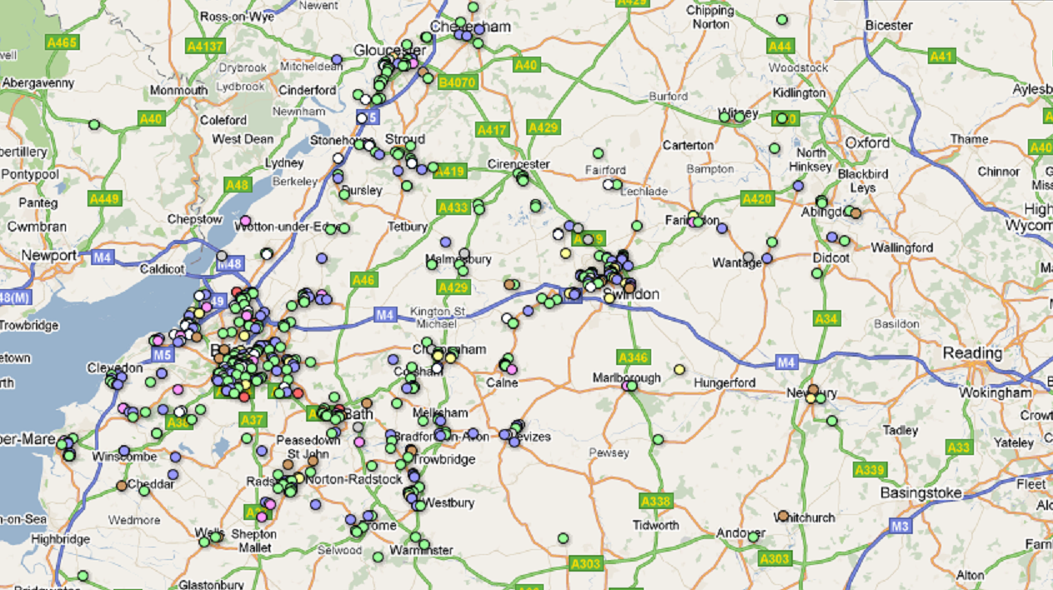
KEY TO MAP (SECTORS)
●  ●  ●  ●  ●  ●  ●  ● | = building and construction  = chemical processing  = engineering  = manufacturing  = mineral /fuel /metal  = transport  = public sector  = transport
2. Value Proposition and Questionnaire
A value proposition was developed identifying who we were, the reason for participating and what the potential value might be. A list of research questions was then agreed which focused on companies’ current provision for training and development. Although questions were also included about potential future training needs and interest in working with the University and its partners, it was agreed that the emphasis would be on the research aspect and the development of a longer-term relationship.
Meetings were held with each of the partners at the start of the process and their views sought. Whilst they weren't directly involved in the design of the questionnaire, their views informed it. They received copy of the findings but, due to changes that have been taking place, follow up meetings are still to take place.
3. Telephone Questionnaires
Companies were contacted between June and September 2011 to identify their current position and needs with regard to training, learning and CPD.
172 companies were contacted of the 435 validated on record representing 5.9% confidence intervals (i.e. +/- 5.9%) at the 95% confidence level. 50 companies were interviewed or 11.5% of the total market defined.
The roles of those interviewed were mainly at senior manager and executive level; 80% of those spoken to had sole responsibility for learning and training across their organisation. Collectively they represented approximately 95,000 out of the 99,000 or so employees in the defined market. In the largest organisations the person responsible for training/CPD was a Learning and Development specialist (responsible for an average workforce of 3500 employees). Where the interviewee was an HR or Personnel Manager, their average workforce was close to 2000 employees. In only 8.7% of cases was the person responsible for training a technical specialist.
Fig 2: Job titles of those interviewed.
 | JOB TITLE | ~% | Average number of employees at these companies | No of these companies >1000 employees | Total number of employees
Exec /Senior Level Learning /Training Specialist | Director /Head of Training /Group Talent /Group Training /Group L & D Manager /Group Team Performance | 37.0 | 3538 | 14 | 60,150
Exec level HR/Personnel | Group Head /Director of HR /Personnel | 8.7 | 445 | 0 | 1780
Personnel /HR with responsibility for training and development | HR /Personnel Manager | 28.3 | 1439 | 2 | 18,712
 | HR Business Partner /Learning Advisor /Senior Officer /Section Manager Training /Health and Safety | 10.8 | 2914 | 2 | 14,568
Senior Technical Training Specialist | Operations Director /Site Engineer  Technical Training Manager /Project Engineer | 8.7 | 188 | 0 | 906
Training administrator or co-ordinator | Training co-ordinator | 2.2 | 3000 | 1 | 3000
Training administrator or co-ordinator | Admin Manager (responsible for HR or L&D) | 4.3 | 77 | 0 | 154
Total |  |  |  |  | 99,270

4. Follow up Calls, Letters and Visits
The 50 companies that agreed to take part in the research provided information on the composition of their workforces, anticipated growth strategies, training and development and opportunities for working with the partners in the future.
All 50 companies who took part were provided with a follow up letter and copy of the outcomes of the research. Unfortunately, due to changes at the University between December 2011 and 2012, it was not possible to hold an event as originally planned.
A programme of company visits and follow up telephone calls was drawn up and proved to be enjoyable and rewarding. The visits, in particular, highlighted the value of face-to-face communication and elicited different and richer information than the calls.

Evaluation:

This sub-project has been evaluated against the original aims as shown below.

Aim 1: To generate specific market information and intelligence about engineering employers’ training and CPD to understand more fully their behaviours and demands.

This aim has been achieved. The University and its partners now have a substantial amount of market information and intelligence about employers’ training and CPD to understand more fully their behaviours and demands. This is both in terms of the information shared under the ‘Discussion, Learning and Impact’ section below, but also in terms of the sensitive data which we have collected from individual employers about their specific needs.

Aim 2: To ascertain current levels of market penetration, overlaps and gaps in coverage by the University and colleges.
This aim has been partially achieved to date but will require ongoing effort as it is a very complex picture involving courses in a range of subject areas at different levels. We have a much clearer idea about what employers want but are now equally aware of the complexity of what we can potentially offer and the difficulties of communicating this in a coherent and meaningful way.
We have a good idea about what companies are buying, what they need and what they may need in the future. The visits also highlighted other possibilities. For example, discussion with one company revealed that language/cultural awareness training may be useful although this was something that they had not previously perceived to be a requirement.
Aim 3: To develop innovative and co-operative working between the University and the colleges such that it can better meet the wide needs of employers and can lead to sustainable engagement across the region and between the four institutions.
This has been partially achieved but will require ongoing, sustained effort. The initial co-operation between the University and colleges was good with all parties sharing their contacts. There is a will on both sides for this co-operation to continue although, due to a number of internal and external policy changes this year, the nature of the partnership will change and we do not yet have a clear idea about the effect that this may have. Staffing changes at the University has also had a negative impact on the progress made in this area and the level of resource required to build and maintain relationships has become apparent. Issues have also emerged around whether or not we are able to satisfy the demand that our efforts generate.
General comment
The CPD Office had very limited staff in place during this project (effectively 1.5 FTE) and, even though we used external consultants to conduct the telephone questionnaire, I think we underestimated the time it would take to follow up each of the calls, send out letters which were tailored to each company's needs and arrange/conduct visits. What we found was that, to do this properly, you needed to have someone dedicated to it on a full-time basis. The next stage, which is around working with companies and identifying/meeting their needs is even more labour-intensive.

Discussion, Learning and Impact:

Findings
Those who are responsible for CPD, learning and development in the companies have a wide range of job titles. More usually they are responsible for all learning and development, consulting with specialist staff (or responding to them) to identify any technical training needs. There appeared to be an opportunity to support this group by develop learning and training expertise and explore the potential for sharing best practice.
Despite the current economic climate, 88% of the companies interviewed stated that their companies (in terms of workforce numbers) are currently stable or growing. Only 12% said their workforce was declining and these held in common the fact they were public sector organizations, or they depend significantly on public sector contracts.
Only 18% of the companies interviewed indicated that the composition of their workforces is changing. There was no common reason discernable, equal numbers of companies are increasing the proportion of administrative and support staff compared with technical or production staff as are reducing it. This reflects perhaps the different companies’ business strategies that are in place to help them manage their way through the current economic conditions. There was no evidence that companies are looking to reduce their production workforce by outsourcing overseas.
All companies interviewed provide training and learning for their employees. The two highest ranked reasons given for undertaking training were:
- to ensure employees can carry out their jobs to satisfy current clients or project;
- to provide development for existing staff to support their progression in the company (and assume more responsibility/grow internal expertise).
These two are the significant drivers reported for undertaking training and also reflect the impact of the current economic environment. A number of companies reported that they were less keen to recruit new skills and expertise because of the additional costs and risks involved. It is currently more attractive, efficient and expedient for companies’ to develop capability using their existing resources/workforce.
More than 70% of companies indicated that their future training will remain similar to that which they presently provide. Where there are predicted changes to the nature of training, the most common changes are expected to be in the format of the training undertaken principally a decrease in classroom based learning and an increase in the use of e-learning, self-directed learning and more flexible, small group training.
It was surprising to find that very few of those interviewed were easily able to quantify how much training occurs in their companies by either the number of training days/hours per employee or the numbers of employees concerned. However, where there were responses the average time spent on training per employee ranged from 1.5 to 5 days each year.
75% of the companies spoken to said they thought there is potential to work with the University and Colleges. We recognise that this proportion may be as high as it is because an element of ‘self-selecting’ will have already occurred during the process of setting up and introducing the purpose of the interview.
Many of the companies contract FE Colleges (including beyond the University’s Associate Colleges) and work with private training providers to supply them with work-based and technical learning at apprenticeships level; the indication is that this seems set to increase.
Only 12% of those interviewed thought there would not be an opportunity to work together in respect of training and learning. In most cases this was because of one of two reasons; either the company trained its employees itself because of the specific nature of their manufacturing processes or the company was already contracted to a supplier they were very happy with.
A number of interviewees indicated that they would prefer a local supplier in preference to a supplier of training that they have at present who is located outside the region.
Learning Points

- Labour market information is an important first step in determining skills gaps and for gaining an understanding of the market in general but cannot provide in-depth information about individual employers’ needs.
- There are good opportunities for developing CPD provision for employers (although this may better be termed learning or training).
- A huge amount of staff time and resource is required to build and maintain relationships with employers. It is essential that suitable staff members are selected to undertake this work and that training and support is offered.
- Face-to-face dialogue and exchange of information with key decision makers is vital in order to gain a full understand of their requirements.

Further Development and Sustainability

Will the activity continue in the future?

Yes (in a modified form). The emphasis in the immediate future will be on developing the relationships with key companies rather than approaching others. In this way it is hoped that we can develop some bespoke training solutions which meet the employers’ needs. We will also be looking to roll out the project to other sectors.

Approaches to Sustainability | Examples | In relation to your project
Continuance (finding alternative sources of funding) | Commitment from institutions to provide continuation funding  - Network/ communities likely to be sustained through inclusion in future funding bids | We will look to allocate a percentage of the CPD Office’s operating budget to employer engagement activities
Embedding (within institutional activity) | - Identification of institutional strategies that the project has informed  - Uptake which has taken place, or is likely to take place, within own/other HEIs  - Influencing of organisations external to HE Sector which has occurred through partnership working | Work is taking place with other University departments to introduce a common CRM system
Mainstreaming (changes in working practices) | - Staff development which is planned or has taken place as a result of your project  - Curriculum enhancement that has occurred or is likely to take place as a result of your project  - Influence of senior managers that has arisen as a result of the project | Training is planned to prepare academic staff in particular to assist them with the development of courses for commercial clients
Legacy (passing on important elements of the project) | - Networks/communities likely to be continued  - Dissemination of project outputs  - Evidence of impact of activities  - Creative Learning Journey material made available via the SW Spoke Creative STEM website where relevant. | We will look to continue the work with the partner colleges and introduce a business referral model  - Presentation at the SW Spoke’s University of Bath institutional seminar, 30.1.12  - Presentation at the SW Spoke’s Workforce Development & Employability Conference, Exeter, 18.6.12

